ARTICLE



Correlations for undrained shear strength of Finnish soft clays

Marco D’Ignazio, Kok-Kwang Phoon, Siew Ann Tan, and Tim Tapani Länsivaara

**Abstract:** The study focuses on the derivation of transformation models for undrained shear strength (*s*u) of Finnish soft sensitive clays. Speciﬁc correlation equations for *s*u of Finnish clays are presented in this work for the ﬁrst time. Field and laboratory measurements from 24 test sites in Finland are exploited for this purpose and a multivariate database is constructed. The multivariate data consist of *s*u from the ﬁeld vane test, preconsolidation stress, vertical effective stress, liquid limit, plastic limit, natural water content, and sensitivity. The main objective is to evaluate the interdependence of *s*u, consolidation stresses, and index parameters and provide a consistent framework for practical use. The new correlations are established through regression analyses. The constructed framework is further validated by another independent multivariate database of clays from Sweden and Norway as well as by empirical equations for Swedish and Norwegian clays. Existing correlations are evaluated for Finnish and Scandinavian clays. Finally, bias and uncertainties of the new correlations are presented.

*Key words:* global transformation models, soft clays, multivariate database, undrained shear strength.

**Résumé :** L’étude porte sur la dérivation de modèles de transformation pour la résistance non drainée au cisaillement (*s*u) des argiles douces sensibles ﬁnlandaises. Des équations de corrélation spéciﬁques pour la *s*u des argiles ﬁnlandaises sont présentées dans cette œuvre pour la première fois. Des mesures sur-le-champ et en laboratoire de 24 sites d’essai en Finlande sont exploitées a` cette ﬁn et une base de données multivariée est construite. Les données multivariées se composent de *s*u a` partir de l’essais d’un scissomètre, de la contrainte de préconsolidation, de la contrainte efﬁcace verticale, de la limite de liquide, de la limite plastique, de la teneur naturelle en eau et de la sensibilité. L’objectif principal est d’évaluer l’interdépendance de la *s*u, des contraintes de consolidation et les paramètres d’index et a` fournir un cadre cohérent pour une utilisation pratique. Les nouvelles corrélations sont établies par analyse de régression. Le cadre construit est en outre validé par une autre base de données multivariée indépendante des argiles de Suède et de la Norvège, ainsi que par des équations empiriques pour les argiles suédoises et norvégiennes. Les corrélations existantes sont évaluées pour les argiles ﬁnlandaises et scandinaves. Enﬁn, les biais et les incertitudes des nouvelles corrélations sont présentés. [Traduit par la Rédaction]

*Mots-clés :* modèles de transformation globale, argiles molles, base de données multidimensionnelle, résistance au cisaillement.

# Introduction

Soft sensitive clays are widespread in Scandinavia, especially on coastal areas. The high compressibility of these soils, along with their low undrained shear strength (*s*u) (even lower than 10 kPa near the ground surface), makes geotechnical design often rather challenging. Therefore, *s*u needs to be carefully evaluated for a reliable assessment of the safety level.

Scandinavian soft clays are typically slightly over consolidated. The overconsolidation is normally the result of the aging process (e.g., Bjerrum 1972). For quick clays, the remolded undrained shear strength (*s*re) can be even less than 0.5 kPa and 50–100 times lower than the initially “intact” *s*u (e.g., Rankka et al. 2004; Karlsrud and Hernandez-Martinez 2013).

u

*s*u can be evaluated from in situ as well as laboratory tests. In Scandinavia, the ﬁeld vane (FV) test and piezocone cone penetration (CPTU) test are the most commonly used in situ tests. Laboratory tests include undrained triaxial compression (TXC) and direct simple shear (DSS) tests. For some special cases where *s*u anisotropy needs to be assessed, triaxial extension (TXE) tests are also performed.

In situations where *s*u is not directly measured or measurements are considered to be unreliable, *s*u is commonly evaluated from transformation models based on clay properties, such as vertical preconsolidation pressure (*C*p*l* ) (e.g., Mesri 1975; Jamiolkowski et al.1985) or plasticity (e.g., Hansbo 1957; Chandler 1988). Such transformation models are typically empirical or semi-empirical, obtained by data ﬁtting through regression analyses (e.g., Kulhawy and Mayne 1990). However, such models must be carefully applied and their limitations be recognized, as soil properties, soil behavior, and site geology may differ from the data source from where the transformation models are calibrated. As a direct consequence, predictions from these models may result in biases with respect to the actual property (*s*u) values.

According to Phoon and Kulhawy (1999), uncertainty coming from transformation models can be customarily categorized as epistemic, meaning that it can be reduced by collecting a greater number of data or improving the available models. Therefore, “global” models, calibrated from data sets covering several sites and soil types, are preferred to “site-speciﬁc” models, which are restricted to a speciﬁc soil type or a speciﬁc site. Ching and Phoon (2012*a*, 2012*b*, 2014*a*, 2014*b*) presented global models based on soil

[Can. Geotech. J. Downloaded from www.nrcresearchpress.com](http://www.nrcresearchpress.com/) by Auchmuty Library on 04/15/17 For personal use only.

Received 23 January 2016. Accepted 13 June 2016.

**M. D’Ignazio* and T.T. Länsivaara.** Department of Civil Engineering, Tampere University of Technology, Korkeakoulunkatu 5, 33720, Tampere, Finland.

**K.-K. Phoon and S.A. Tan.** Department of Civil and Environmental Engineering, National University of Singapore, No. 1 Engineering Drive 2, 117576, Singapore.

**Corresponding author:** Marco D’Ignazio (emails: [marco.dignazio@tut.ﬁ](mailto:marco.dignazio@tut.fi); [marco.dignazio@ngi.no](mailto:marco.dignazio@ngi.no)).

*Present address: Norwegian Geotechnical Institute (NGI), Sognsveien 72, N-0855 Oslo, Norway.

Copyright remains with the author(s) or their institution(s). Permission for reuse (free in most cases) can be obtained from [RightsLink](http://www.nrcresearchpress.com/page/authors/services/reprints).

Can. Geotech. J. **53**: 1628–1645 (2016) [dx.doi.org/10.1139/cgj-2016-0037](http://dx.doi.org/10.1139/cgj-2016-0037) Published at [www.nrcresearchpress.com/cgj](http://www.nrcresearchpress.com/cgj) on 13 June 2016.

u p v

|  |  |  |  |  |  |  |  |
| --- | --- | --- | --- | --- | --- | --- | --- |
| **Table 1.** Summary of multivariate clay databases.  Range of properties | | | | | | | |
|  |  |  | No. of data | No. of sites |  |  |  |
| Database | Reference | Parameters of interest | points | or studies | OCR | PI | *S*t |
| CLAY/5/345 Ching and Phoon LI, *s*u, *s*re, *Cl* , *Cl* 345 | | | | 37 sites | 1~4 — Sensitive to | | |
| (2012*a*) | | | |  | quick clays | | |
| CLAY/7/6310 Ching and Phoon *s*CIUC, *s*CK0UC, *s*CK0UE, *s*DSS, *s*FV, *s*UU, *s*UC 6310 | | | | 164 studies | 1~10 Low to very high Insensitive to | | |
| (2013) | | | |  | plasticity quick clays | | |
| CLAY/6/535 Ching et al. (2014) *s*u/*C*p*l* , OCR, (*q*t − *C*v)/*C*v*l* , (*q*t − *u*2)/*C*v*l* , 535 40 sites 1~6 Low to very high Insensitive to  (*u*2 − *u*0)/*C*v*l* , *B*q plasticity quick clays | | | | | | | |
| CLAY/10/7490 | Ching and Phoon | LL, PI, LI, *C*v*l* /*P*a, *C*p*l* /*P*a, *s*u/*C*v*l* , *S*t, | 7490 | 251 studies | 1~10 | Low to very high | Insensitive to |
|  | (2014*a*) | (*q*t − *C*v)/*C*v*l* , (*q*t − *u*2)/*C*v*l* , *B*q |  |  |  | plasticity | quick clays |

u u u u u u u

data covering a large number of test sites from several countries. Ching and Phoon (2012*b*) pointed out how site-speciﬁc models are more accurate (or less uncertain) than global models, although bias can be signiﬁcant when applied to another site. Instead, global models are less biased, although less precise (or more uncertain).

Global transformation models for *s*u of Swedish and Norwegian F-CLAY/10/173 is evaluated by calculating the biases and uncertain- ties associated with S-CLAY/10/168.

# Overview on existing transformation models for undrained shear strength

The dependency of *s*u on *C*p*l* and plasticity has been the object of

clays are available in the literature (Larsson and Mulabdic 1991;Larsson et al. 2007; Karlsrud and Hernandez-Martinez 2013). How- ever, a comparable model calibrated using a sufﬁciently large soil research over the last decades, because of its practical usefulness. Skempton (1954) suggested a linear correlation between the normalized *s*u determined from FV test (*s*FV/*Cl* ) and plasticity index (PI)

u v

database containing Finnish soft clay data is still missing. Therefore, the main objectives of the present paper are (*i*) to test existing transformation models for *s*u for Finnish soft clays and (*ii*) to derive, for the ﬁrst time, transformation models for *s*u speciﬁc to Finnish soft clays using a large multivariate database consisting of FV data points from Finland. Another independent multivariate database of FV data points from Sweden and Norway is compiled

for normally consolidated clays. Subsequently, Chandler (1988) indicated that the same correlation could be valid also for over- consolidated clays as shown in eq. (1), although attention must be paid when dealing with ﬁssured, organic, sensitive or other spe- cial clays.

*s*FV

and used for comparison and validation.

The value of multivariate soil databases has been demonstrated by Ching and Phoon (2012*a*, 2012*b*, 2013, 2014*a*, 2014*b*) and Ching et al. (2014). Müller (2013), Müller et al. (2014, 2016), and Prästings et al. (2016) have demonstrated how uncertainties related to *s*u can

(1)

u ≈ 0.11 + 0.0037PI

*C*p*l*

Hansbo (1957) suggested, for Scandinavian clays, that *s*FV/*Cl* is

u p

be reduced when multivariate soil data are available, showing the beneﬁts of using multivariate analyses (e.g., Ching et al. 2010) in geotechnical engineering applications. Multivariate soil data- bases are, however, limited in the literature. A summary is given in Table 1. Ching and Phoon (2014*a*) proposed labeling a multivar-

directly proportional to LL. Larsson (1980), collected strength data

points from FV test in Scandinavian clays and proposed a trans- formation model similar to eq. (1), as described by eq. (2)

*s*FV

iate database as “soil type”/“number of parameters of interest”/ “number of data points”. Based on this nomenclature, the two databases presented in this paper are (*i*) F-CLAY/7/216 for Finnish

(2)

u

*C*p*l*

≈ 0.08 + 0.0055PI

clays (where “F” stands for Finland) and (*ii*) S-CLAY/7/168 for Scan-

According to Bjerrum (1972), *s*FV needs to be converted into mo-

dinavian clays (where “S” stands for Scandinavia). The seven pa-

rameters in these databases consisted of *s*u from the FV test (*s*FV),

u

u

bilized *s*u(*s*u(mob) ≈ *s*FV*入*). The parameter *入*

u

is a correction multi-

effective vertical stress (*Cl*v), vertical preconsolidation pressure (*C*p*l* ), natural water content (*w*), liquid limit (LL), plastic limit (PL), and sensitivity (*S*t = *s*u/*s*re).

u

The paper is organized as follows. Firstly, after a brief overview on existing transformation models for *s*u, the compilation of F-CLAY/7/216 and S-CLAY/7/168 databases is presented. Secondly, 10 dimensionless parameters are derived from the seven basic pa- rameters, resulting in two dimensionless databases. These dimen- sionless databases (labelled as F-CLAY/10/216 and S-CLAY/10/168) are compared to existing correlations in the literature. To develop more reﬁned correlations for Finnish clays, outliers are removed from F-CLAY/10/216 according to systematic criteria based on soil nature, mechanical characteristics, and statistical considerations. New transformation models for *s*u speciﬁc to Finnish clays are derived through regression analyses from the resulting F-CLAY/10/

plier that accounts for rate effects as well as anisotropy, and it is thought to be dependent on the plasticity of the clay.

Mesri (1975, 1989) suggested a unique relationship for *s*u(mob) of clays and silts, corresponding approximately to DSS condition (eq. (3)), regardless of the plasticity of the clay.

(3) *s*u(mob) ≈ 0.22

*C*p*l*

However, according to Larsson (1980), eq. (3) tends to overesti- mate *s*u in very low–plastic clays, while it underestimates *s*u in high-plastic clays. For low overconsolidated clays with low to mod- erate PI, Jamiolkowski et al. (1985) recommended (eq. (4))

173 database. These new transformation models are compared with existing correlations for Scandinavian clays from the litera- ture. Finally, the performance of the new models derived from

[Can. Geotech. J. Downloaded from www.nrcresearchpress.com](http://www.nrcresearchpress.com/) by Auchmuty Library on 04/15/17 For personal use only.

(4)

*s*u(mob)

*Cl*v

≈ (0.23 ± 0.04)OCR0.8

The transformation model suggested by Jamiolkowski et al. (1985) is based on the stress history and normalized soil engineer- ing properties (SHANSEP) framework (eq. (5)) proposed by Ladd and Foott (1974). The SHANSEP framework is normally adopted to describe the variation of *s*u with the overconsolidation ratio, OCR

(= *C*p*l* /*Cl*v).

(5) *s*u = *S*(OCR*m*)

*Cl*v

where *S* and *m* are constants dependent on material and test type. *S* represents the normalized *s*u for normally consolidated state. The exponent *m* varies between 0.75 and 0.95 (Jamiolkowski et al. 1985). A value of *m* equal to 0.8 is often assumed in practice. Note

shear strength that is mobilized in a full-scale failure of an em- bankment or slope in the ﬁeld (Bjerrum 1972; Mesri and Huvaj 2007). *s*u(mob) cannot be uniquely deﬁned, as it is a function of failure mode, stress state, and strain rate, among others. In this

study, the *s*FV values are converted into *s*u(mob) values through a correction factor *入* , as reported in the Finnish Guidelines for sta- bility analysis (Ratahallintokeskus 2005). In this way, rate effects

u

and anisotropy are implicitly accounted for. The strength correc- tion factor used is expressed by eq. (9)

(9) *入* = 1.5

1 + LL

According to Jamiolkowski et al. (1985) and Chandler (1988), *s*u

obtained from FV is somewhat comparable to *s*u from DSS test

that *m* = 1 would reduce eq. (5) to eq. (3) with *S* = 0.22.

*l* results. It is common practice in Sweden to consider *s*u from DSS

Larsson et al. (2007) studied the SHANSEP relation between *s*u/*C*v

and OCR for inorganic Scandinavian clays. Data from undrained

TXC, DSS, and TXE tests were collected to assess *s*u anisotropy. By assuming an average *m* value equal to 0.8, it was shown how the normally consolidated undrained shear strength ratio (*S*) is mate- rial dependent for DSS (eq. (6)) and TXE, as it increases with in- creasing liquid limit; while it seems fairly constant for TXC.

Karlsrud and Hernandez-Martinez (2013) studied the (*s*u/*Cl*v)–OCR relation for Norwegian soft clays from laboratory tests on high-

quality block samples. Outcomes from this study indicate that *s*u strongly correlates with natural water content (*w*) combined with OCR (eq. (7) for DSS strength). More speciﬁcally, peak strengths from TXC, DSS, and TXE test were observed to increase with in- creasing *w*. Possible reasons to explain this might be e.g., (*i*) the open structure typical of Norwegian clays (Rosenqvist 1953, 1966), which allows the soil to retain a quantity of pore water, typically above the liquid limit of the soil or (*ii*) the increasing rate effects with plasticity.

*s*DSS

tests as a reference value (e.g., Westerberg et al. 2015). DSS tests may, however, be affected by some disturbance effects resulting from sampling as well as specimen preparation. In Finland, DSS tests are not in use and the FV test is normally assumed to provide reliable *s*u values, despite some issues related to test equipment. As suggested by Mansikkamäki (2015), when casing is used to protect the vane during penetration into the ground, rod friction is minimized and, therefore, measured torque values are assumed to be less biased than when slip-coupling is used. FV data points from Finland collected in this study are mostly obtained using FV test equipment that includes casing. As a consequence, the results presented later will likely be representative of the best possible estimate of *s*FV in Finnish current practice.

The database is compiled from data given in Gardemeister (1973), Lehtonen et al. (2015), together with data from recent soil investigations performed by Tampere University of Technology, Finland (J. Selänpää, personal communication, 2015). Gardemeister (1973) collected FV and oedometer tests performed at different construction sites in Finland. For the purpose of the present

u

(6)

(7)

u ≈ (0.125 + 0.205LL/1.17)OCR0.8

*Cl*v

*s*DSS

u ≈ (0.14 + 0.18*w*)OCR(0.35+0.77*w*)

*Cl*v

study, sites characterized by organic (organic content higher than 2%) and (or) silty soils have been discarded, because the focus of this study is on the strength of inorganic clays. Some low organic clays may, however, be present in the database.

This database is labeled as F-CLAY/7/216 following the nomen- clature proposed by Ching and Phoon (2014*a*). F-CLAY/7/216 is a new database that would contribute to the list of multivariate soil

Ching and Phoon (2012*a*) proposed a global transformation model for *s*u(mob) from FV and unconﬁned compression (UC) tests as a function of OCR and *S*t. The model was built based on a large database of structured clays (CLAY/5/345) consisting of 345 clay data points from several locations all over the world (eq. (8)).

(8) *s*u(mob) ≈ 0.229OCR0.823*S*0.121

databases shown in Table 1. The basic statistics of the seven clay parameters in F-CLAY/7/216 are listed in Table 2. The parameters *Cl*v and *C*p*l* are normalized to the atmospheric pressure, *P*a (*P*a = 101.3 kPa).

The numbers of available data points (*n*) are reported in the sec-

ond column. The statistics shown are the mean value, coefﬁcient of variation (COV), minimum value (Min) and maximum value (Max). Clay properties cover a wide range of *S*t values varying from

*Cl*v

t

# Analysis of multivariate clay databases

## F-CLAY/7/216 and S-CLAY/7/168

The ﬁrst clay database compiled in this study consists of 216 FV data points from 24 different test sites from Finland. Each data “point” contains multivariate information, i.e., information from different tests conducted in close proximity is available. The col- lected data points contain information on seven basic parameters

measured at comparable depths and sampling locations: *s*FV, *Cl* ,

2 (insensitive clays) to 64 (quick clays), and a wide range of PI

values (2~95) and *w* values (25~150).

A second independent database consisting of 168 FV data points from Sweden and Norway is extracted from the existing global CLAY/10/7490 database (Ching and Phoon 2014*a*). This database is labelled as S-CLAY/7/168 and it contains multivariate information on the same soil parameters as in F-CLAY/7/216. The purpose of S-CLAY/7/168 is to act as an independent set of data to be used for comparison with F-CLAY/7/216 in subsequent analyses. The geo- graphical coverage of S-CLAY/7/168 is restricted to Sweden (12 sites)

and Norway (seven sites). Full information on all seven parameters

*C*p*l* , *w*, LL, PL, and *S*t.

u v

is available for only 59 data points. Fortunately, for the remaining

The standard FV test is normally carried out at high speed of rotation, inducing strain rates in the soil that are much higher than in conventional laboratory tests (e.g., triaxial tests, DSS

tests). The main consequence is that *s*FV is overestimated and,

109 data points, information on all six parameters with the excep- tion of St is known. The practical implication here is that the effect of *S*t on *s*u correlations is more difﬁcult to discern in the case of S-CLAY/7/168. Basic statistics of the seven clay parameters in

u FV

therefore, a correction is needed to convert *s*u into *s*u(mob) (e.g., Bjerrum 1972). The parameter *s*u(mob) is deﬁned as the undrained

[Can. Geotech. J. Downloaded from www.nrcresearchpress.com](http://www.nrcresearchpress.com/) by Auchmuty Library on 04/15/17 For personal use only.

S-CLAY/7/168 are reported in Table 3. The multivariate clay data con- tained in F-CLAY/7/216 and S-CLAY/7/168 are listed in Appendix A.

**Table 2.** Basic statistics of the seven basic parameters in F-CLAY/7/216.

|  |  |  |  |  |  |
| --- | --- | --- | --- | --- | --- |
| Variable | *n* | Mean | COV | Min | Max |
| *s*FV (kPa) | 216 | 21.443 | 0.501 | 5 | 75 |
| *C*v*l* /*P*a | 216 | 0.464 | 0.485 | 0.074 | 1.609 |
| *C*p*l* /*P*a | 216 | 0.948 | 0.515 | 0.251 | 2.884 |
| LL | 216 | 66.284 | 0.298 | 22.0 | 125.0 |
| PL | 216 | 27.740 | 0.204 | 10.0 | 50.0 |
| *w* | 216 | 76.340 | 0.268 | 25.0 | 150.0 |

u

*S*t 216 17.447 0.789 2.0 64.0

**Table 3.** Basic statistics of the seven basic parameters in S-CLAY/7/168.

|  |  |  |  |  |  |
| --- | --- | --- | --- | --- | --- |
| Variable | *n* | Mean | COV | Min | Max |
| *s*FV (kPa) | 168 | 16.346 | 0.505 | 5.62 | 48.75 |
| *C*v*l* /*P*a | 168 | 0.503 | 0.632 | 0.068 | 2.101 |
| *C*p*l* /*P*a | 168 | 0.786 | 0.726 | 0.150 | 3.116 |
| LL | 168 | 71.055 | 0.396 | 22.77 | 201.81 |
| PL | 168 | 29.448 | 0.344 | 2.73 | 73.92 |
| *w* | 168 | 76.631 | 0.347 | 17.27 | 180.11 |

u

*S*t 59 12.068 0.779 3.0 42.5

**Fig. 1.** Plasticity chart.

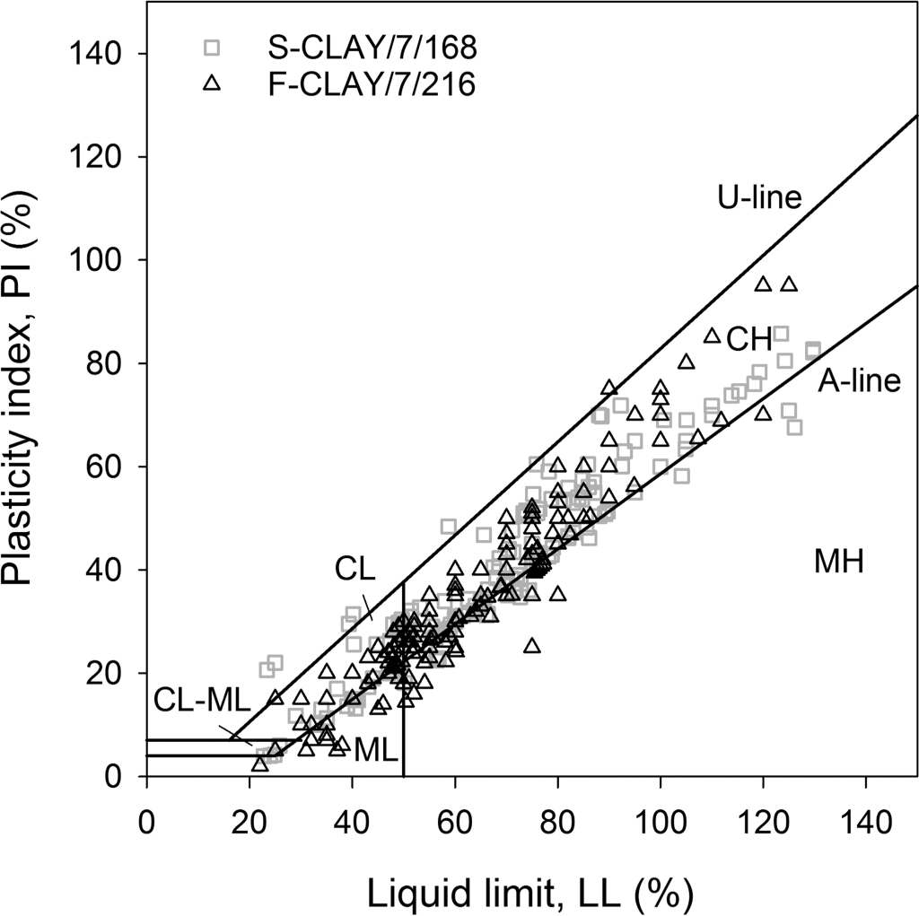

Figure 1 shows how the data points are positioned in the plas- ticity chart to provide a broad physical overview of the databases. Figure 2 suggests that *w* tends to increase for increasing LL, and that *w* is higher than LL for the majority of the data points.

## Dimensionless databases: F-CLAY/10/216 and S-CLAY/10/168

Ten dimensionless soil parameters are of primary interest in this study. They are derived from the seven basic clay parameters appearing in F-CLAY/7/216 and S-CLAY/7/168 and they can be cate- gorized into two groups:

1. Index properties, including natural water content (*w*), liquid limit (LL), plasticity index (PI), and liquidity index (LI).
2. Stresses and strengths, including OCR, normalized *s*u(mob) against vertical effective stress [*s*u(mob)/*Cl*v] and preconsolida-

tion pressure [*s*u(mob)/*C*p*l* ], normalized *s*FV against vertical ef-

**Fig. 2.** Water content (*w*) versus liquid limit (LL) for F-CLAY/7/216 and S-CLAY/7/168.

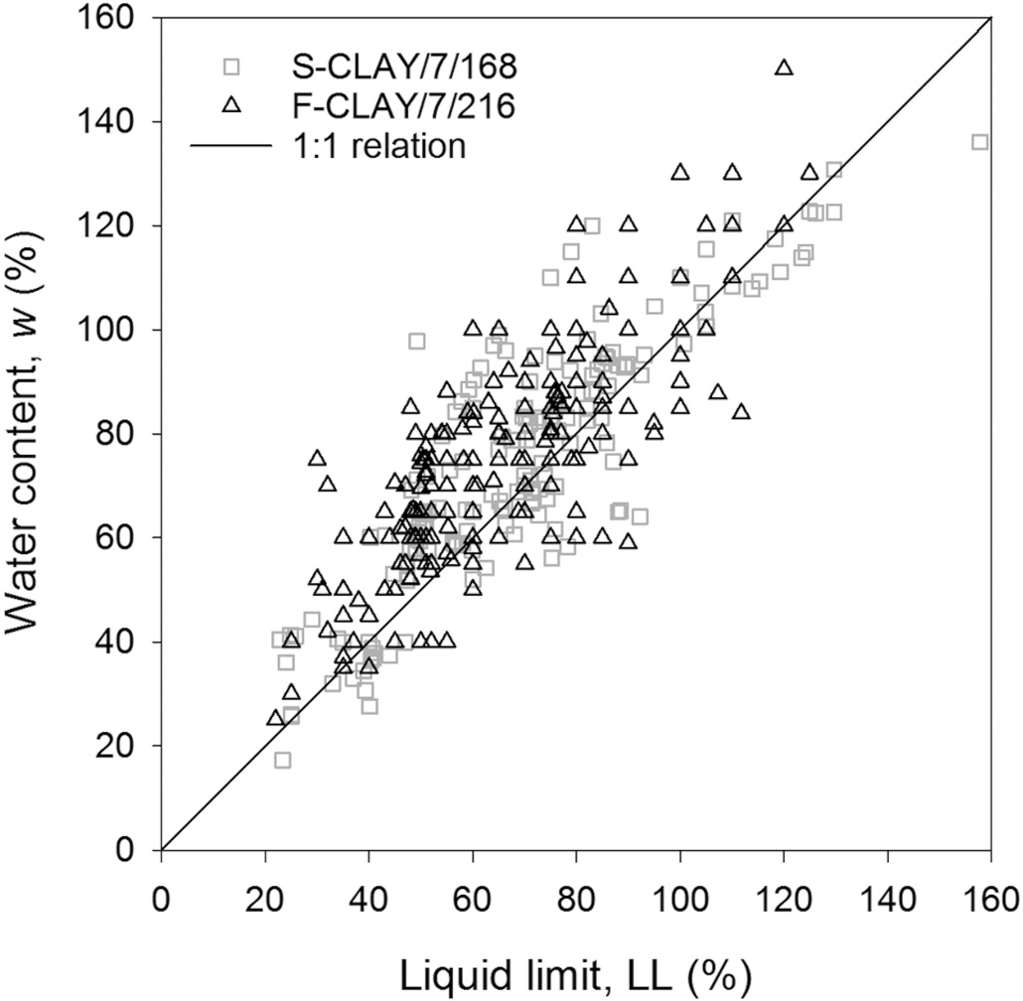

Figure 3*a* shows the *s*u(mob)/*Cl*v values plotted against OCR for F-CLAY/10/216 and S-CLAY/10/168. The trend described by the *s*u(mob)/*Cl*v points vs. OCR seem on average higher for Finnish clays than for Scandinavian clays. The reason for such a discrepancy could lie in the deﬁnition of *C*p*l* used to estimate OCR. Indeed, *C*p*l* is normally determined through an oedometer test and it is strongly affected by

the strain rate used in the test (e.g., Leroueil et al. 1983, 1985). As suggested by Leroueil et al. (1985) and Leroueil (1988, 1996), constant rate of strain (CRS) oedometer tests provide stress–strain curves that normally differ from those provided by conventional 24 h incremen- tally loaded (IL) oedometer tests. The main reason for such differ- ences can be found in the different rate of loading (or rate of straining) applied during the test. According to Leroueil and Soares Marques (1996), the strain rate in IL test after 24 h is between 1 × 10−7 s−1 for highly compressible clays and 5 × 10−8 s−1 for low com- pressible clays. The strain rate in CRS tests is normally between 1 ×

10−6–4× 10−6 s−1. As a consequence, *C*p*l* is larger in CRS than in the 24 h IL test (Leroueil 1996). More speciﬁcally, Leroueil (1996) suggests that *C*p*l* obtained from the CRS oedometer test is typically 25% larger than that deduced from the IL test. For Finnish clays, Kolisoja et al. (1989) reported, for one site in Finland, the ratio *C*p*l* CRS/*C*p*l* IL to be equal to

1.16. Hoikkala (1991) observed the same ratio to be equal to 1.3 for

three different sites in Finland. Länsivaara (1999), based on the data collected by Leroueil (1996) on several types of clays, suggested *C*p*l* CRS/ *C*p*l* IL = 1.27. Karlsrud and Hernandez-Martinez (2013) observed, for

oedometer tests conducted on block samples of Norwegian clays, that *C*p*l* values derived from the IL tests were 10%–18% lower than for the CRS tests.

Upon examination of the original sources (listed in Table A1 of Ching and Phoon (2014*a*)) from where data contained in S-CLAY/

7/168 have been collected, it seems that *C*p*l* points were mostly measured from CRS oedometer tests. F-CLAY/7/216 contains only 56 *C*p*l* CRS points, while the remaining 162 points are from 24 h IL tests (*C*p*l* IL) (Fig. 3*a*). Therefore, to make data suitable for compari- son, *C*p*l* IL is increased by 27% for all data points as a ﬁrst-order correction following the proposal by Länsivaara (1999) (Fig. 3*b*). By

applying *Cl* /*Cl* = 1.27 to all 162 *Cl* values from Finland, the

fective stress (*s*FV/*Cl*

u

*s*FV/*Cl* ),

pCRS

pIL

pIL

u v) and preconsolidation pressure ( u p

[Can. Geotech. J. Downloaded from www.nrcresearchpress.com](http://www.nrcresearchpress.com/) by Auchmuty Library on 04/15/17 For personal use only.

and sensitivity (*S*t = *s*u/*s*re).

u

strength points from F-CLAY/10/216 seem to better adapt to the

*s*u(mob)/*Cl*v – OCR trend shown by those contained in S-CLAY/10/168

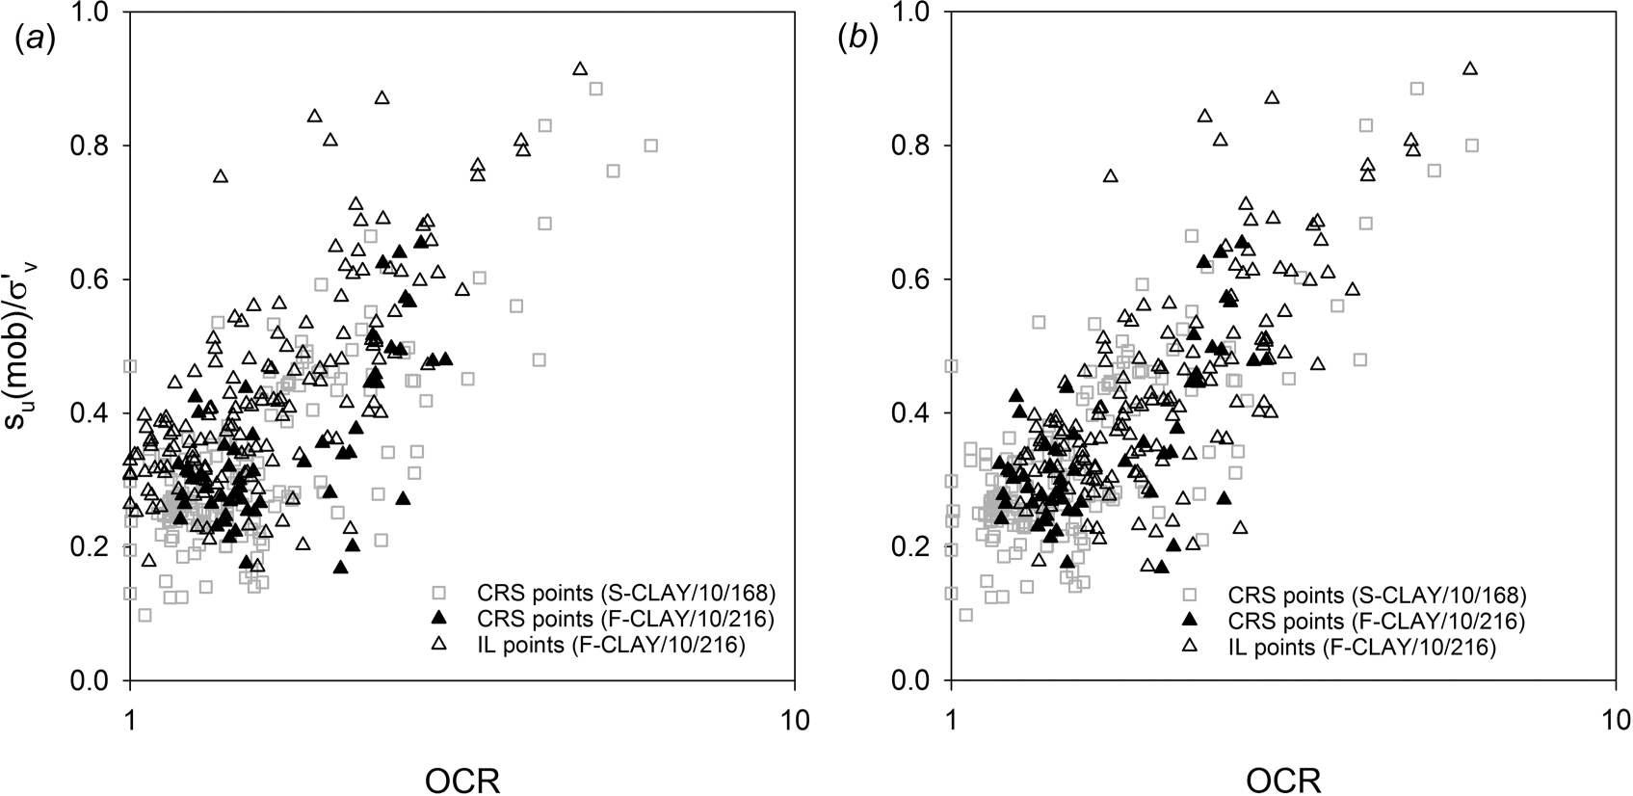**Fig. 3.** *s*u(mob)/*C*v*l* against OCR for (*a*) raw data points and (*b*) data points corrected to *C*p*l* from CRS oedometer test using *C*p*l* CRS/*C*p*l* IL = 1.27.

(Fig. 3*b*). It is plausible that the difference between F-CLAY/10/216 and S-CLAY/10/168 in the *s*u(mob)/*Cl*v versus OCR plot is primarily caused by the difference between the CRS and IL test, rather than

the difference between clay types, as also indicated by Fig. 1 and Fig. 2.

The basic statistics of the 10 dimensionless parameters are

|  |  |  |  |  |  |
| --- | --- | --- | --- | --- | --- |
| Variable | *n* | Mean | COV | Min | Max |
| su(mob)/*C*v*l* | 216 | 0.458 | 0.715 | 0.167 | 2.754 |
| su(mob)/*C*p*l* | 216 | 0.209 | 0.281 | 0.081 | 0.469 |
| *s*FV/*Cl* 216 | | 0.513 | 0.712 | 0.176 | 2.938 |
| *s*FV/*Cl* 216 | | 0.234 | 0.293 | 0.083 | 0.594 |
| OCR | 216 | 2.170 | 0.467 | 1.18 | 7.50 |
| LL | 216 | 66.284 | 0.298 | 22.0 | 125.0 |
| PI | 216 | 38.545 | 0.482 | 2.0 | 95.0 |
| *w* | 216 | 76.340 | 0.268 | 25.0 | 150.0 |
| LI | 216 | 1.443 | 0.459 | 0.425 | 4.800 |

**Table 4.** Basic statistics of 10 dimensionless soil parameters in F-CLAY/ 10/216, derived from the seven basic parameters in F-CLAY/7/216.

listed in Table 4 and Table 5 for the dimensionless databases, u v

labeled as F-CLAY/10/216 and S-CLAY/10/168, respectively. u p

## Comparison with existing transformation models

The 384 clay data points constituting F-CLAY/10/216 and S-CLAY/ 10/168 databases are compared with transformation models pro-

posed in the literature to check their consistency. It is worth pointing out that transformation models are generally derived based on certain types of clays and geographical locations. The basis for these models is usually empirical. Very often, for such models we do not know the basic statistics (such as those reported in Table 4 and Table 5).

The 10 transformation models analyzed are labeled using the following template: “primary input parameter”–“target parameter”–

|  |  |  |  |  |  |  |
| --- | --- | --- | --- | --- | --- | --- |
| “secondary input parameter”. They are categorized into four types | *s*u(mob)/*C*p*l* | 168 | 0.210 | 0.269 | 0.088 | 0.470 |
| (see e.g., Table 6): | *s*FV/*Cl* | 168 | 0.386 | 0.469 | 0.098 | 0.974 |
| *Type A* — Models for *S* , including two LI–(*s*re/*P* ) models and two | *s*FV/*Cl*  OCR | 168  168 | 0.244  1.664 | 0.311  0.476 | 0.088  1.00 | 0.490  6.07 |
| LI–(*S*t) models. | LL | 168 | 71.06 | 0.396 | 22.77 | 201.81 |
| *Type B* — Models for effective stress, including one LI–(*C*p*l* /*P*a)–*S*t | PI | 168 | 41.61 | 0.496 | 3.91 | 127.89 |
| model. Basic statistics of *C*p*l* /*P*a are reported in Table 2 and Table 3 | *w* | 168 | 76.63 | 0.347 | 17.27 | 180.11 |

*S*t 216 17.447 0.789 2.0 64.0

**Table 5.** Basic statistics of 10 dimensionless soil parameters in S-CLAY/ 10/168, derived from the seven basic parameters in S-CLAY/7/168.

Variable *n* Mean COV Min Max

*s*u(mob)/*C*v*l* 168 0.329 0.417 0.098 0.885

u v

u p

t u a

and not included in the dimensionless databases, as *s*FV and

u

LI 168 1.267 0.507 0.60 5.50

*s S*t 59 12.068 0.779 3.00 42.50

u(mob) are the parameters of primary interest for this study.

*Type C* — Models for shear strength, including one PI–[*s*u(mob)/*C*p*l* ] model, one OCR–[*s*u(mob)/*Cl*v] model, and one OCR–[*s*u(mob)/*Cl*v]–*S*t model.

*Type D* — Models for shear strength, including two PI–(*s*FV/*Cl* ),

Figures 4–11 show the comparison between databases and trans-

formation models. For the LI–(*C*p*l* /*P*a)–*S*t and OCR–[*s*u(mob)/*Cl*v]–*S*t

one LL–(*s*FV/ *l*

u p models by Ching and Phoon (2012*a*), data points are divided into

u *C*p). These three models are compared to uncorrected

*s*FV ( *入* correction factor is not applied), being originally derived

two groups according to *S*t values. The two groups are based on the

u

from uncorrected measurements.

Many of the transformation models are derived empirically us- ing regression analyses. Only the LI–(*s*re/*P*a) model by Wroth and

distinction between “low to medium sensitive” (*S*t < 15) and “highly sensitive” (*S*t > 15) clays suggested by Karlsrud and Hernandez-Martinez (2013) for Norwegian clays.

The OCR–[*s* (mob)/*Cl* ] transformation model by Jamiolkowski

u u v

Wood (1978) represents an exception. It is derived theoretically from the modiﬁed Cam clay model. The LI–(*C*p*l* /*P*a)–*S*t and OCR– [*s*u(mob)/*Cl*v]–St models proposed by Ching and Phoon (2012*a*) are

[Can. Geotech. J. Downloaded from www.nrcresearchpress.com](http://www.nrcresearchpress.com/) by Auchmuty Library on 04/15/17 For personal use only.

derived from sensitive structured clay data. The LI–*S*t model by

Bjerrum (1954) is based on Norwegian marine clay data.

et al. (1985) provides a reasonable average ﬁt to the data. For OCR < 8, *s*u(mob)/*Cl*v seems to be strongly dependent on OCR (Fig. 4). A deviation from the trend line in Fig. 4 is visible at OCR

values greater than 5. However, data points with OCR > 5 belong to layers located in proximity of the ground surface (above 1.50 m)

**Table 6.** Transformation models in literature and their calibration results for F-CLAY/10/216.

Comparison to F-CLAY/10/216

database

Calibration results

|  |  |  |  |  |  |  |  |  |  |
| --- | --- | --- | --- | --- | --- | --- | --- | --- | --- |
|  | | | | | | Fit to the |  | Bias | COV of |
| Type | Relationship | Literature | *n* | Transformation model | Figure | trend? |  | factor, *b* | e = *o* |

A LI–(*s*re/*P*a) Wroth and Wood (1978) 216 *s*re/*P*a ≈ 1.7−4.6LI 9 No — —

u u

Locat and Demers (1988) 216 *s*re/*P*a ≈ 0.0144LI−2.44 9 Yes 4.05 3.02

u

|  |  |  |  |  |  |  |  |  |
| --- | --- | --- | --- | --- | --- | --- | --- | --- |
| LI–(St) | | Bjerrum (1954) | 216 | *S*t ≈ 100.8LI | 11 | Yes | 1.56 | 1.40 |
|  | | Ching and Phoon (2012*a*) | 216 | *S*t ≈ 20.726LI1.910 | 11 | No | 0.57 | 1.94 |
| B LI–(*C*p*l* /*P*a)–*S*t (for *S*t < 15) | | Ching and Phoon (2012*a*) | 216 *C*p*l* /*P*a ≈ 0.235LI−1.319*S*0.536 12a Yes 2.02 0.94  t | | | | | |
| LI–(*C*p*l* /*P*a)–*S*t (for *S*t > 15) | | Ching and Phoon (2012*a*) | 216 *C*p*l* /*P*a ≈ 0.235LI−1.319*S*0.536 12a Yes 0.95 0.47  t | | | | | |
| C | PI–(*s*u(mob)/*C*p*l* ) | Mesri (1975, 1989) | 216 | *s*u(mob)/*C*p*l* ≈ 0.22 | 5 | Yes | 0.95 | 0.28 |
| OCR–[*s*u(mob)/*C*v*l* ] | | Jamiolkowski et al. (1985) | 216 | *s*u(mob)/*C*v*l* ≈ 0.23OCR0.8 4 Yes 1.06 0.30 | | | | |
| OCR–[*s*u(mob)/*C*v*l* ]–*S*t | | Ching and Phoon (2012*a*) | 216 | *s*u(mob)/*C*v*l* ≈ 0.229OCR0.823*S*0.121 6a Yes 0.77 0.32  t | | | | |
| D | LL–(*s*FV/*Cl* ) | Hansbo (1957) | 216 | *s*FV/*Cl* ≈ 0.45LL | 7 | Yes | 0.84 | 0.38 |
|  | PI–(*s*FV/*Cl* ) | Larsson (1980) | 216 | *s*FV/*Cl* ≈ 0.08 + 0.0055PI | 8 | Yes | 0.89 | 0.43 |
|  |  | Chandler (1988) | 216 | *s*FV/*Cl* ≈ 0.11 + 0.0037PI | p 8 | Yes | 0.97 | 0.35 |

u p u p

u p u p

u

**Fig. 4.** OCR–[*s*u(mob)/*C*v*l* ] model proposed by Jamiolkowski et al. (1985).

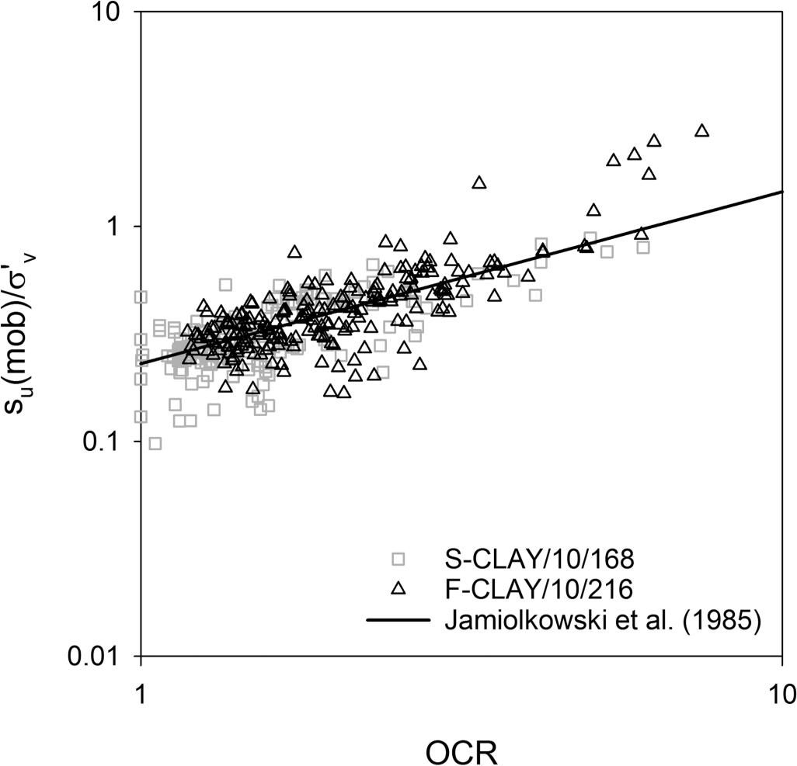

where the clay might be ﬁssured and (or) partially saturated. Therefore, the interest for those points is limited, because the focus of this study is on intact clays.

The PI–[*s*u(mob)/*C*p*l* ] model by Mesri (1975, 1989) takes out the dependency of *s*u(mob) on PI, stating that *s*u(mob)/*C*p*l* is constant and equal to 0.22. From Fig. 5, *s*u(mob)/*C*p*l* seems independent of PI, thus conﬁrming the suggestion given by Mesri.

The dependency of *s*u on St predicted by the OCR–[*s*u(mob)/*Cl*v]–*S*t

**Fig. 5.** PI–[*s*u(mob)/*C*p*l* ] model proposed by Mesri (1975, 1989).

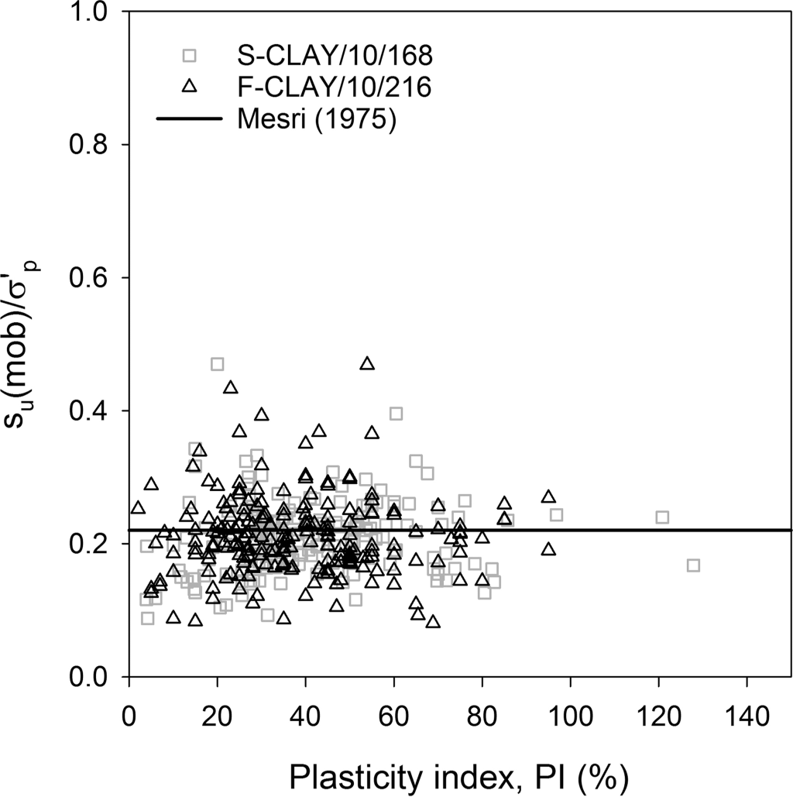

Data points seem to depart from the LI–(*s*re/*P*a) model by Wroth and Wood (1978) for LI values greater than 1 (Fig. 9). However, the transformation model by Locat and Demers (1988) seems able to reproduce the trend observed for LI<2 (Fig. 9). For LI > 2, the data points deviate from the existing transformation models. The au- thors believe that *S*t was determined from the FV test for some of the Finnish data points (from Gardemeister 1973). The FV test is

u

known to produce higher *s*re values than the conventional fall

model by Ching and Phoon (2012*a*), is not visible from the col-

u

u

cone (FC) test. Tanaka et al. (2012) demonstrated how

*s*re deter-

lected data points (Fig. 6). However, the majority of the F-CLAY/10/ 216 data points for *S*t < 15 are located between the *s*u(mob)/*Cl*v–OCR trend lines for *S*t = 1 and *S*t = 15 (Fig. 6*a*).

It is quite difﬁcult to observe a well-deﬁned trend for the data

points to the LL–(*s*FV/*Cl* ) model by Hansbo (1957) (Fig. 7). Both data-

mined from the FV test and the laboratory vane test (LVT) is as much as tenfold larger than *s*re determined using the FC test (Fig. 10*b*). This was attributed to the different remolding methods, as the turning of the vane is not equivalent to the remolded state

for the FC test, which is obtained by kneading by hand. Hence, the

u

u p re

bases seem to better adapt to the mean trend suggested by the PI–

(*s*FV/*Cl* ) models (Fig. 8), although high scatter can be observed along

actual *s*u may be lower than that shown in Fig. 9, which conse- quently produces a higher *S*t. However, there are only 29 points

u p

the trend lines suggested by Larsson (1980) and Chandler (1988, after Skempton 1954).

Can. Geotech. J. Downloaded from [www.nrcresearchpress.com](http://www.nrcresearchpress.com/) by Auchmuty Library on 04/15/17 For personal use only.

with LI > 2. The conclusions of this study will be largely unaf- fected, because 29 points only constitute 13.4% of the total num-

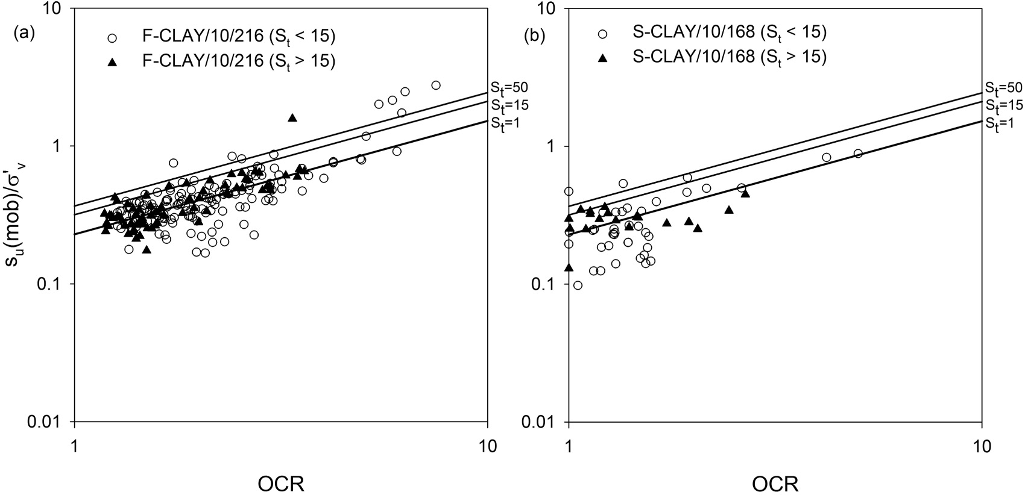**Fig. 6.** OCR–[*s*u(mob)/*C*v*l* ]–*S*t model by Ching and Phoon (2012*a*) for (*a*) F-CLAY/10/216 and (*b*) S-CLAY/10/168.

**Fig. 7.** LL–(*s*FV/*Cl* ) model proposed by Hansbo (1957). **Fig. 8.** PI–(*s*FV/*Cl* ) models proposed by Larsson (1980) and Chandler

u p u p

(1988).

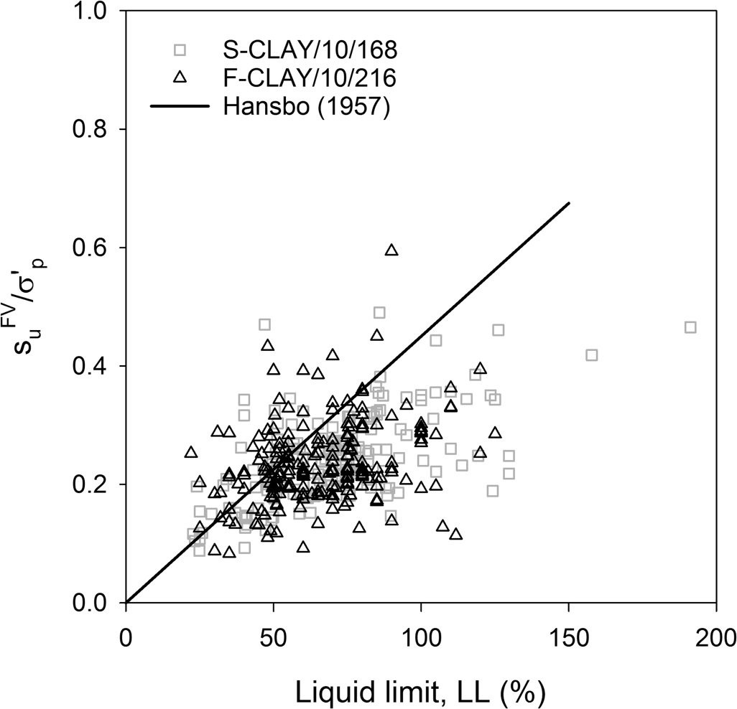 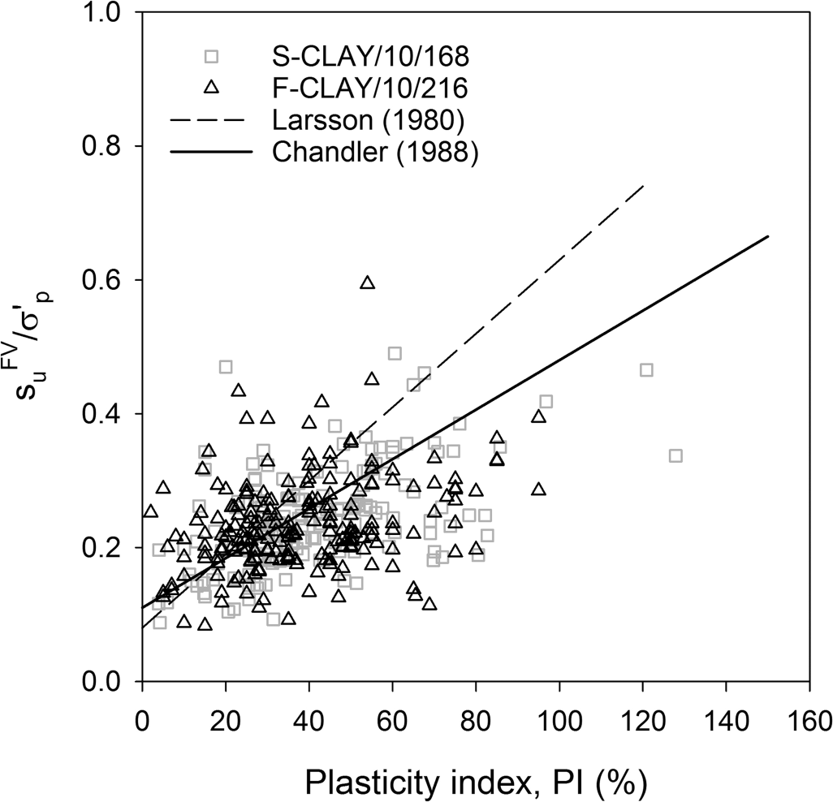

ber of points. Based on the experimental results presented by Tanaka et al. (2012), the authors would like to further suggest that while undisturbed *s*u values from FV and FC can be mixed (as shown in Fig. 10*a*), *s*re or derived parameters (*S*t) between FV and FC should be treated separately (as suggested by Fig. 10*b*).

[Can. Geotech. J. Downloaded from www.nrcresearchpress.com](http://www.nrcresearchpress.com/) by Auchmuty Library on 04/15/17 For personal use only.

u

The LI–(*S*t) model by Bjerrum (1954) can reasonably describe the data points for LI < 2, despite the high scatter observed (Fig. 11). In contrast, the global model by Ching and Phoon (2012*a*) seems to provide an upper bound rather than an average ﬁt to the data- bases (Fig. 11).

The LI–(*C*p*l* /*P*a)–*S*t model by Ching and Phoon (2012*a*) does not seem to ﬁt the data points in F-CLAY/10/216 for *S*t < 15 (Fig. 12*a*). The LI–(*C*p*l* /*P*a)–*S*t transformation model appears to provide a better description of the highly sensitive clays (*S*t > 15) in F-CLAY/10/216,

as the majority of the points are contained in the interval between the LI–(*C*p*l* /*P*a)–*S*t lines for *S*t = 15 and St = 50 (Fig. 12*a*). In contrast, for the low to medium sensitive clays (*S*t < 15) in S-CLAY/10/168, most of the data points are comprised between the LI–(*C*p*l* /*P*a)–*S*t bound-

ary lines for *S*t = 1 and *S*t = 15 (Fig. 12*b*), while for the highly sensitive clays, the models cannot satisfactorily describe the ob- served values.

## Bias and uncertainties of the existing transformation models

Bias factor (denoted by *b*), and COV (denoted by *o*) are evaluated

and discussed for the transformation models described in the

previous section, based on the F-CLAY/10/216 and S-CLAY/10/168 databases. The parameters *b* and *o* represent the sample mean and the COV, respectively, of the ratio (actual target value)/(predicted

target value). If *b* = 1, the model prediction is unbiased. For instance, for the OCR–[*s*u(mob)/*Cl*v] transformation model by Jamiolkowski et al. (1985), the actual target value is *s*u(mob)/*Cl*v and

the predicted target value is 0.23OCR0.8. For the data points where *s*u(mob)/*Cl*v and OCR are simultaneously known, (actual target value)/ (predicted target value) = [*s*u(mob)/*Cl*v]/(0.23OCR0.8).

**Fig. 9.** LI–(*s*re/*P*a) models.

[Can. Geotech. J. Downloaded from www.nrcresearchpress.com](http://www.nrcresearchpress.com/) by Auchmuty Library on 04/15/17 For personal use only.

u

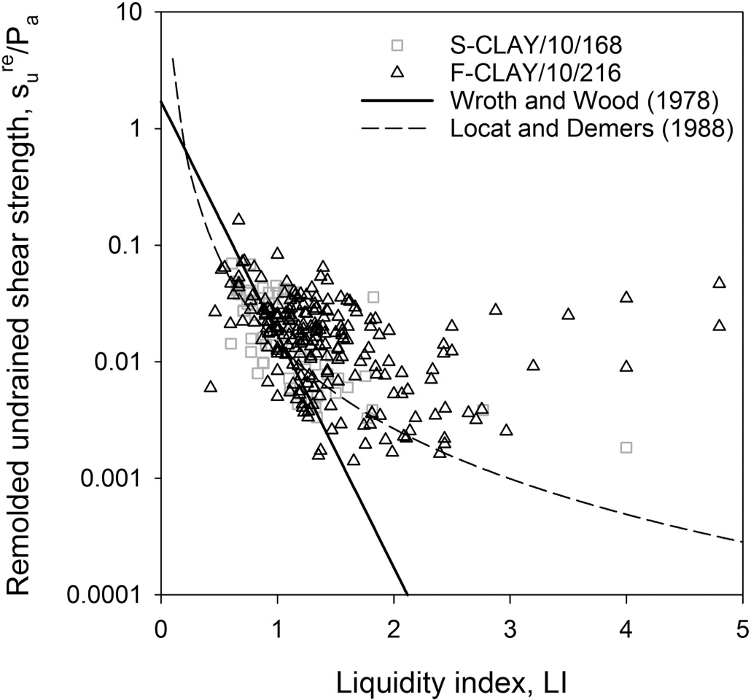

**Fig. 10.** Comparison of strengths measured by FC, FV, and LVT at

1. undisturbed and (*b*) remolded conditions (Tanaka et al. 2012).

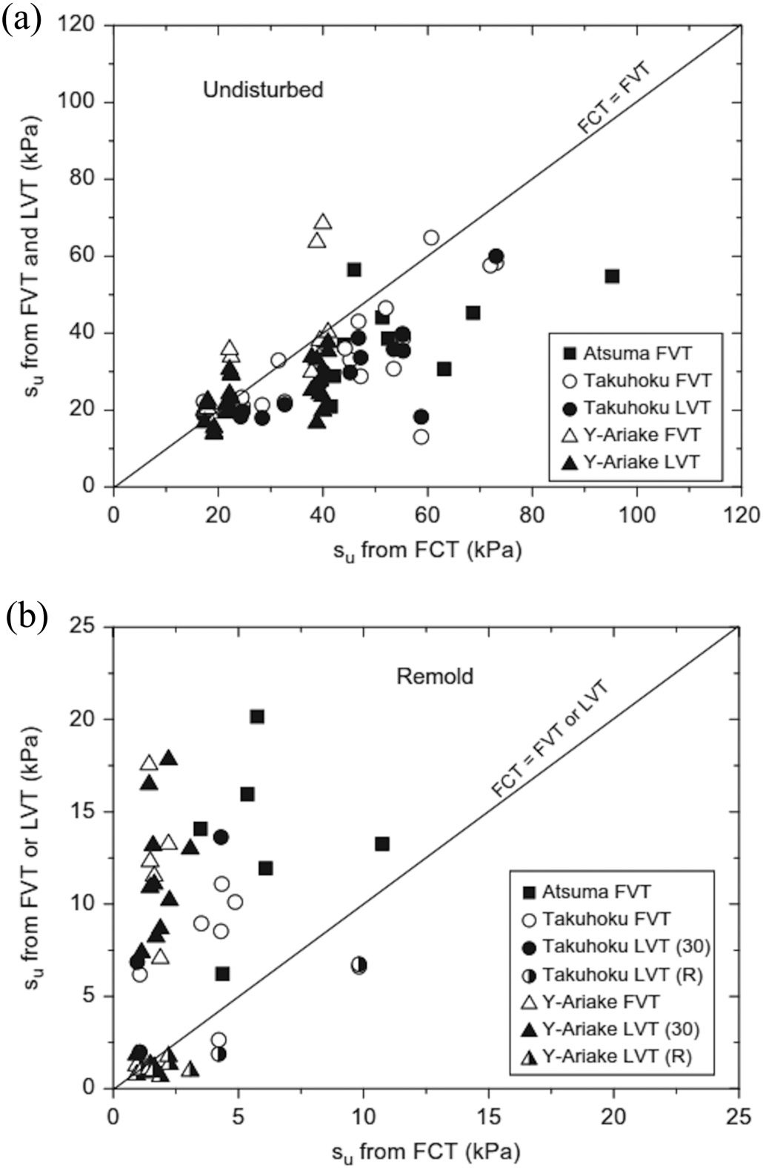

**Fig. 11.** LI–*S*t models.

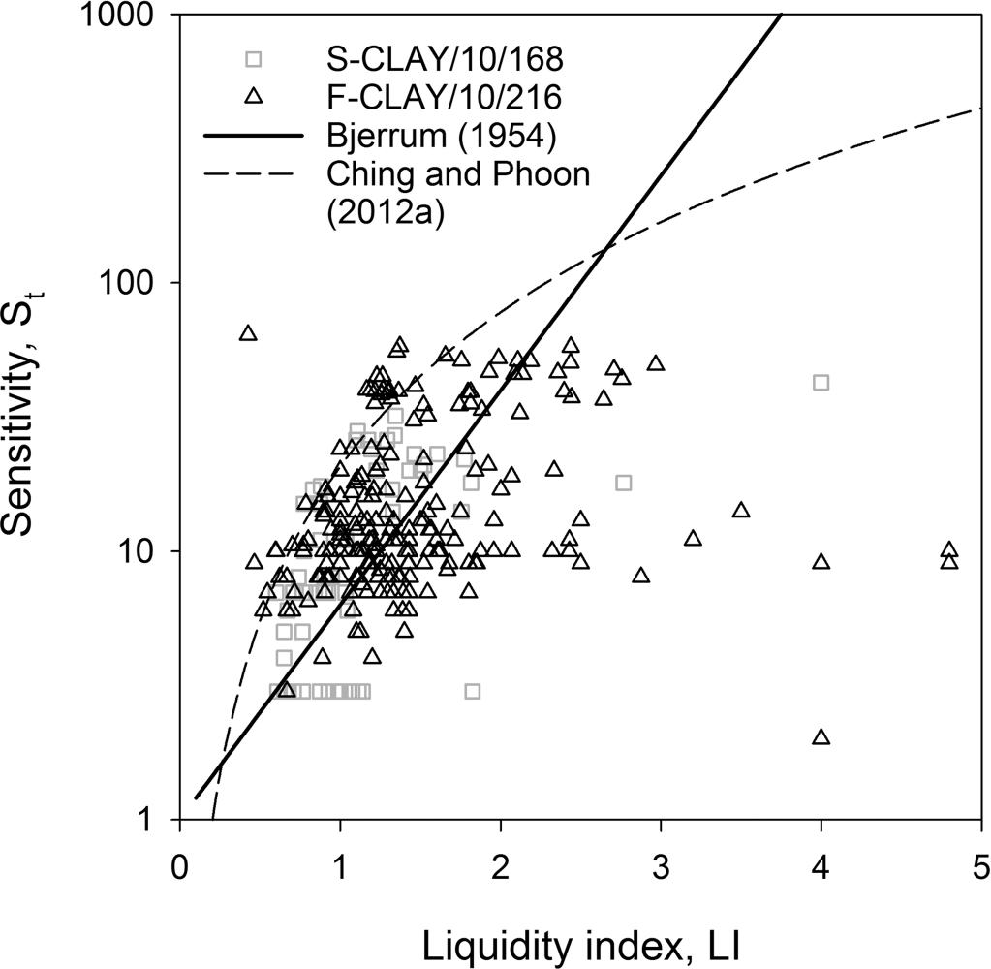

According to Ching and Phoon (2014*a*):

e= (actual target value)/(*b* × predicted target value)

= (actual target value)/(unbiased prediction)

where e is the variability term with mean = 1 and COV = *o*. If *o* = 0, there is no data scatter about the transformation model, indicat-

ing that the prediction is deterministic, rather than uncertain.

Bias factors and COVs for the different transformation models

analyzed are reported in Table 6 for F-CLAY/10/216 and Table 7 for S-CLAY/10/168, respectively. Bias factor, COV of e, and number of data points used for each calibration are denoted, respectively, by *b*, o, and *n*.

The LI–(*s*re/*P*a) model by Locat and Demers (1988) seems quite

u

conservative, as it underpredicts the actual value by a factor of

4.05 for Finnish clays (Table 6) and 1.60 for Scandinavian clays (Table 7). Bjerrum’s (1954) transformation model underestimates the actual *S*t values for both Finnish and Scandinavian clays. Nev- ertheless, the uncertainty underlying these predictions still re- mains considerable, as the COV for type A models ranges between 61% and 302%. A similar analysis can be carried out for the LI–

(*C*p*l* /*P*a)–*S*t model by Ching and Phoon (2012*a*). The deviation of about 50%–60% from the mean trend lines of both F-CLAY/10/216

and S-CLAY/10/168, combined with a COV greater than 1 and equal to 0.61 for Finnish and Scandinavian clays, respectively, would result in predicted values characterized by a high degree of uncer- tainty. Therefore, models of type A and B are “biased” models with respect to both databases.

In contrast, different outcomes are obtained for the transforma- tion models of type C and D (models for shear strength). Models

of type C (*s*u(mob)/*Cl*v is the target parameter) show bias factors

1. close to 1 and COV (*o*) lower than 0.30. Exception is found for the OCR–[*s*u(mob)/*Cl*v]–*S*t model (Ching and Phoon 2012*a*), which shows a bias factor of 0.71–0.77 with a COV of 0.32–0.36. These

results would thus suggest that *s*u(mob) of Scandinavian clays can be described by different well established transformation models with relatively low uncertainty. For instance, the equation by Mesri (1975, 1989) can be adapted to Finnish soft clays by including the bias factor (*b*) calibrated from F-CLAY/10/216 database as

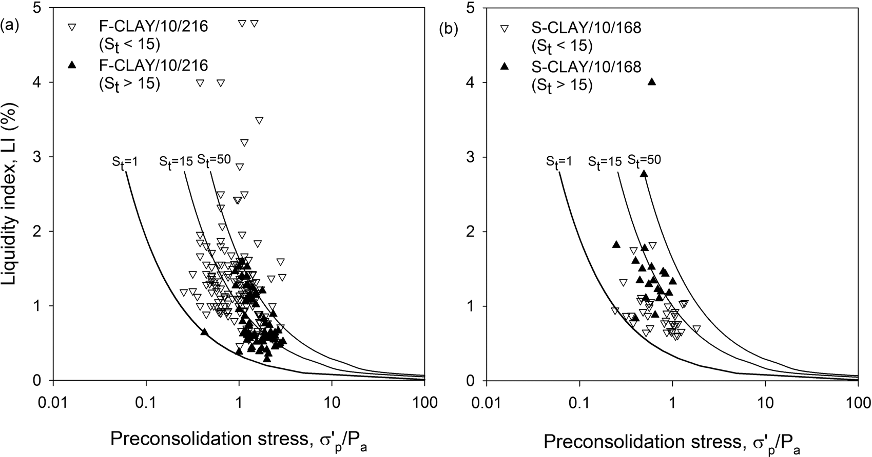**Fig. 12.** LI–(*C*p*l* /*P*a)–*S*t model by Ching and Phoon (2012*a*) for (*a*) F-CLAY/10/216 and (*b*) S-CLAY/10/168.

**Table 7.** Transformation models in literature and their calibration results for S-CLAY/10/168.

Comparison to S-CLAY/10/168

database

Calibration results

|  |  |  |  |  |  |  |
| --- | --- | --- | --- | --- | --- | --- |
|  | | | Transformation | Fit to the | Bias | COV of |
| Type Relationship | Literature | *n* | modelmodelmodel Figure | trend? | factor, *b* | e = *o* |

1. LI–(*s*re/*P*a) Wroth and Wood (1978) 59 *s*re/*P*a ≈ 1.7−4.6LI 9 No — —

u u

Locat and Demers (1988) 59 *s*re/*P*a ≈ 0.0144LI−2.44 9 Yes 1.60 0.96

u

|  |  |  |  |  |  |  |  |  |
| --- | --- | --- | --- | --- | --- | --- | --- | --- |
|  | LI–(*S*t) | Bjerrum (1954) | 59 | *S*t ≈ 100.8LI | 11 | Yes | 1.48 | 0.65 |
|  | Ching and Phoon (2012*a*) | 59 | *S*t ≈ 20.726LI1.910 | 11 | No | 0.49 | 0.61 |
| B | LI–(*Cl* /Pa)–*S*t (for *S*t < 15) | Ching and Phoon (2012*a*) | 59 | *Cl* /*P*a ≈ 0.235LI−1.319*S* 0.536 | 12b | Yes | 1.23 | 0.51 |
|  | LI–(*Cl* /*P*a)–*S*t (for *S*t > 15) | Ching and Phoon (2012*a*) | 59 | *Cl* /*P*a ≈ 0.235LI−1.319*S* 0.536 | 12b | Yes | 0.84 | 0.54 |
| C | PI–[*s*u(mob)/*C*p*l* ] | Mesri (1975, 1989) | 168 | *s*u(mob)/*C*p*l* ≈ 0.22 | 5 | Yes | 0.96 | 0.27 |
|  | OCR–[*s*u(mob)/*C*v*l* ] | Jamiolkowski et al. (1985) | 168 | *s*u(mob)/*C*v*l* ≈ 0.23OCR0.8 | 4 | Yes | 0.97 | 0.25 |
|  | OCR–[*s*u(mob)/*C*v*l* ]–*S*t | Ching and Phoon (2012*a*) | 168 | *s*u(mob)/*C*v*l* ≈ | 6b | Yes | 0.71 | 0.36 |
|  |  |  |  | 0.229OCR0.823*S* 0.121 |  |  |  |  |
| D | LL–(*s*FV/*Cl* ) | Hansbo (1957) | 168 | *s*FV/*Cl* ≈ 0.45LL | 7 | Yes | 0.82 | 0.34 |
|  | PI–(*s*FV/*Cl* ) | Larsson (1980) | 168 | *s*FV/*Cl* ≈ 0.08 + 0.0055PI | 8 | Yes | 0.85 | 0.37 |
|  |  | Chandler (1988) | 168 | *s*FV/*Cl* ≈ 0.11 + 0.0037PI | p 8 | Yes | 0.96 | 0.31 |

p p t

p p t

t

u p u p

u p u p

u

*s*u(mob)/*C*p*l* = *b*(0.22) = 0.95(0.22) = 0.209, with a COV (*o*) = 0.28 (low variability).

Type D models (*s*FV/*Cl* is the target parameter, see Tables 6–7)

1. Points located near the ground surface that may belong to ﬁssured upper layers (dry crust), as the study focuses on intact and saturated clays. Dry crust layers are generally unsaturated

u p

show a bias factor *b* varying between 0.82 and 0.97 with COV between 0.31 and 0.43, suggesting reasonably low variability for

these models. In particular, the PI–(*s*FV/*Cl* ) model proposed by

and contain cracks and ﬁssures. *s*u of such soils may be highly overestimated when measured with the FV test (La Rochelle

1974; Lefebvre et al. 1987; D’Ignazio et al. 2015). Dry crust layers

u p

Chandler (1988) results almost “unbiased” with respect to both F-CLAY/10/216 and S-CLAY/10/168, suggesting *b* comprised between

0.96–0.97 and *o* varying between 0.31 and 0.35.

# *s* /*Cl* transformation models for F-CLAY/10/173

in Finland are normally 1–2 m thick. Therefore, points near the ground surface, at depths lower than 1.50 m, are left out.

1. Points with *s*u(mob)/*C*p*l* lower than an initial shear stress mobi- lization (*T*0/*C*p*l* where *T*0 is the initially mobilized shear stress)

**u v** in the soil *T*0/*C*p*l* = 0.5(1 – *K*0) equal to 0.15 for normally consol-

## Removal of outliers in F-CLAY/10/216

[Can. Geotech. J. Downloaded from www.nrcresearchpress.com](http://www.nrcresearchpress.com/) by Auchmuty Library on 04/15/17 For personal use only.

As the scope of this study is to derive transformation models for *s*u of Finnish soft clays that are more reﬁned than the existing models in the literature, the data points collected in F-CLAY/10/216 are analyzed with the purpose of improving the quality of the database by removing outliers. The quality of data points is as- sessed through criteria based on the physical nature of the soil, mechanical characteristics, and statistical considerations. The ad- opted criteria are listed below:

idated state. *K*0 is the earth pressure coefﬁcient at rest calcu- lated from Jaky’s (1944) formula (*K*0 =1– sin *cp l*, where *cp l* is the effective friction angle of the soil). *T*0 = 0.15 implies *cp l* = 18°,

which could represent, according to the authors’ experience,

the lowest boundary value for friction angle of Scandinavian clays.

1. Outliers identiﬁed through the “2*C*” (95% conﬁdence interval of *s*u(mob)/*Cl*v) statistical criteria. “*C*” is the standard deviation of the variable *s*u(mob)/*Cl*v. Data points where, for a given “*i*”

value |[*s*u(mob)/*Cl*v]*i* – mean[*s*u(mob)/*Cl*v]|> 2*C*, are removed. Nor- mally, outliers for a given data set are identiﬁed using the 3C

(three sigma) rule, representing the 99% conﬁdence interval of the data. The reason why in this study the 95% conﬁdence

**Table 8.** Basic statistics of the data points after removal of outliers (database F-CLAY/10/173).

Variable *n* Mean COV Min Max

interval criteria is used, has to do with the inherent soil vari- u v

|  |  |  |  |  |  |
| --- | --- | --- | --- | --- | --- |
| *s* (mob)/*Cl* | 173 | 0.399 | 0.284 | 0.213 | 0.690 |
| *s*u(mob)/*C*p*l* | 173 | 0.213 | 0.183 | 0.148 | 0.338 |
| *s*FV/*Cl* | 173 | 0.447 | 0.306 | 0.226 | 0.920 |
| *s*FV/*C*p*l* | 173 | 0.239 | 0.203 | 0.148 | 0.394 |
| OCR | 173 | 1.91 | 0.31 | 1.18 | 3.69 |
| LL | 173 | 66.4 | 0.29 | 22 | 125.0 |
| PI | 173 | 38 | 0.47 | 2 | 95.0 |
| *w* | 173 | 78.3 | 0.25 | 25.00 | 150.0 |
| LI | 173 | 1.48 | 0.43 | 0.46 | 4.80 |

ability. *s*u proﬁles obtained from the FV test are likely to show

clear ﬂuctuations against a mean trend. Strength variability u v with depth may depend not only on the consolidation stresses u (initial or mechanically induced), but also on the inherent variability of the soil layers (variation of grain size, index proper-

ties). Furthermore, sample disturbance can affect the preconsoli- dation pressure (*C*p*l* ) trend with depth and consequently the ratio

*s* (mob)/*Cl* . To remove these points, a statistical criterion stron-

u p *S*t 173 18.80 0.76 2.00 58.0

ger than the “3*C*” was preferred to a “visual” one.

The number of data points left out is 43 out of 216, correspond-

**Table 9.** Linear regression coefﬁcients for multivariable function *F*.

ing to 20% of the database. To be more speciﬁc, 10, 24, and 9 points

are removed based on criteria 1, 2 and 3, respectively. The out- comes of this study will then be based on 173 higher quality mul-

Transformation model

Secondary input

parameter, *Yj a � 'Y r2*

tivariate clay data points. The updated dimensionless database is hereinafter called F-CLAY/10/173. Updated basic statistics of F-CLAY/10/173 database are listed in Table 8. One major outcome of this procedure is the reduction of the COV for all the analyzed dimensionless variables (see Table 8). Index parameters and sen-

|  |  |  |  |  |  |  |
| --- | --- | --- | --- | --- | --- | --- |
| sitivity are not signiﬁcantly affected by the removal of data points. | OCR–*s*FV/*Cl* –*Yj* | *Y*1 (PI) | 0.328 | 0.756 | 0.165 | 0.68 |
| However, OCR range drops considerably from 1~7.50 to 1~3.70. |  | *Y*2 (LL) | 0.319 | 0.757 | 0.333 | 0.70 |
| Such low OCR values are expected to be found in shallow clay |  | *Y*3 (*w*) | 0.296 | 0.788 | 0.337 | 0.69 |
| deposits in Finland. Therefore, *s*u of Finnish clays for OCR > 4 will |  | *Y*4 (LI) | 0.281 | 0.770 | −0.088 | 0.63 |

OCR–*s*u(mob)/*C*v*l* –*Yj Y*1 (PI) 0.242 0.763 −0.013 0.67

*Y*2 (LL) 0.245 0.760 −0.005 0.67

*Y*3 (*w*) 0.246 0.760 0.027 0.67

*Y*4 (LI) 0.241 0.770 0.045 0.67

*Y*5 (*S*t) 0.242 0.762 0.006 0.67

u v

not be discussed in this study. Moreover, the average *s*u(mob)/*C*p*l* in Table 8 is slightly higher than in Table 4, resulting from the re-

moval of the unreliable data points.

## Derivation of new transformation models

Regression analyses are carried out to derive new transforma- tion models for *s*u of Finnish soft clays. The F-CLAY/10/173 database is used for this purpose. The SHANSEP framework (eq. (5)) pro- posed by Ladd and Foott (1974) is adopted to describe the variation

of *s*u(mob) and *s*FV with OCR and index parameters.

*Y*5 (*S*t) 0.280 0.786 −0.013 0.62

dependent on St. In contrast, a similar conclusion cannot be drawn for the OCR–[*s*u(mob)/*Cl*v]–*Yj* model, as *s*u(mob)/*Cl*v seems to be only lightly correlating with index parameters. This concept can be well understood by looking at the scalar coefﬁcient *'Y* for the OCR–[*s*u(mob)/*Cl*v]–*Yj* models from Table 9. For *'Y* > 0, *s*u(mob)/*Cl*v increases with increasing *Yj*; on the contrary, for *'Y* < 0 it reduces by

increasing *Y* . Although *'Y* values indicate that *s* (mob)/*Cl* decreases

u *j* u v

Larsson et al. (2007) and Karlsrud and Hernandez-Martinez (2013) studied the anisotropic *s*u of Scandinavian and Norwegian clays, respectively, from TXC, DSS, and TXE tests. Larsson et al. (2007) reported *S* and *m* (see eq. (5)) to be dependent on LL (eq. (6) for DSS), while Karlsrud and Hernandez-Martinez (2013) found *w*, combined with the OCR, to be the best index parameter for cor- relating their test results (eq. (7) for DSS). A direct comparison

between *s*DSS and *s*FV would, however, be misleading, if rate effects

with increasing PI or LL and, in contrast, increases with increasing *w*, LI or *S*t, it should be emphasized how *'Y* tends to zero for the OCR–[*s*u(mob)/*Cl*v]–*Yj* transformation model. As a result, *s*u(mob)/*Cl*v

of Finnish soft clays results (*i*) slightly dependent or nearly inde-

pendent of the secondary input variable *Yj*, and (*ii*) strongly depen- dent on the consolidation stresses (increasing with increasing OCR). This result agrees with the ﬁndings of Mesri (1975, 1989) and Jamiolkowski et al. (1985). However, Mesri (1975, 1989) suggests

u u

are not accounted for. Nevertheless, eqs. (6) and (7) will be still used for qualitative comparison.

Linear regression analyses are performed using the “fmin- search” algorithm implemented in the mathematical software MATLAB (Mathworks 1995). The “fminsearch” function (see Mathworks 1995) ﬁnds the minimum of an unconstrained multi- variable function through a derivative free method (unconstrained

linear optimization). The multivariable function *F* = f(*s*u,*i*/*Cl*v, OCR, *Yj*) is deﬁned by eq. (10)

(10) *F* = *s*u,*i* = *a*OCR*�Y'Y*

*j*

*m* = 1, which is not consistent with the results presented in Table 9, as for Finnish clays *m* results lower than 1. To validate such obser- vation, it is worth to mention that the modiﬁed Cam clay model (Schoﬁeld and Wroth 1968) predicts *m* = 1 – *C*s/*C*c, where *C*c and *C*s are the compression and swelling indices, respectively, of a clay. This result indicates that *m* is generally less than 1 for normally consolidated to lightly overconsolidated clays, which are typically known to be adequately modeled by the modiﬁed Cam clay

model. Moreover, by averaging *a* and *�* from the ﬁve OCR–[*s*u- (mob)/*Cl*v]–*Yj* correlation equations of Table 9, and assuming *'Y* = 0, for Finnish clays, eq. (11)

*Cl*v

(11)

*s*u(mob)

≈ 0.244OCR0.763

where *s* , = {*s* , = *s* (mob), *s* , = *s*FV}, *Y* = {*Y* = PI, *Y* = LL, *Y* = *w*, *Y* =

*Cl*v

u *i* u 1 u u 2 u *j* 1 2 3 4

LI, *Y*5 = *S*t}. The scalar coefﬁcients *a*, *�*, and *'Y* and the coefﬁcient of determination (*r*2) for the two newly constructed OCR–(*s*u,*i*/*Cl*v)–*Yj* transformation models are given in Table 9. The *r*2 of the new

correlations ranges from 0.62 to 0.70.

The results of the regression analyses suggest that for the OCR–

(*s*FV/*Cl*)–*Yj* transformation model, *s*FV/*Cl* is directly proportional to

which nearly corresponds to the unbiased transformation model presented by Jamiolkowski et al. (1985), as described earlier in this paper. The calibrated bias factor (*b*) from F-CLAY/10/216 database

for the OCR–[*s*u(mob)/*Cl*v] model by Jamiolkowski et al. (1985) is

equal to 1.06. This means *s*u(mob)/*Cl* = *b*(0.23)OCR0.8 = 0.244OCR0.8

u v u v v

[Can. Geotech. J. Downloaded from www.nrcresearchpress.com](http://www.nrcresearchpress.com/) by Auchmuty Library on 04/15/17 For personal use only.

PI, LL, *w* and inversely proportional to LI, while it is not markedly with a coefﬁcient of variation (COV = *o*) equal to 0.30.

**Fig. 13.** Comparison between OCR–(*s*FV/*Cl* )–LL for Finnish clays and OCR–(*s*DSS/*Cl* )–LL model by Larsson et al. (2007) for Swedish clays.

u v u v

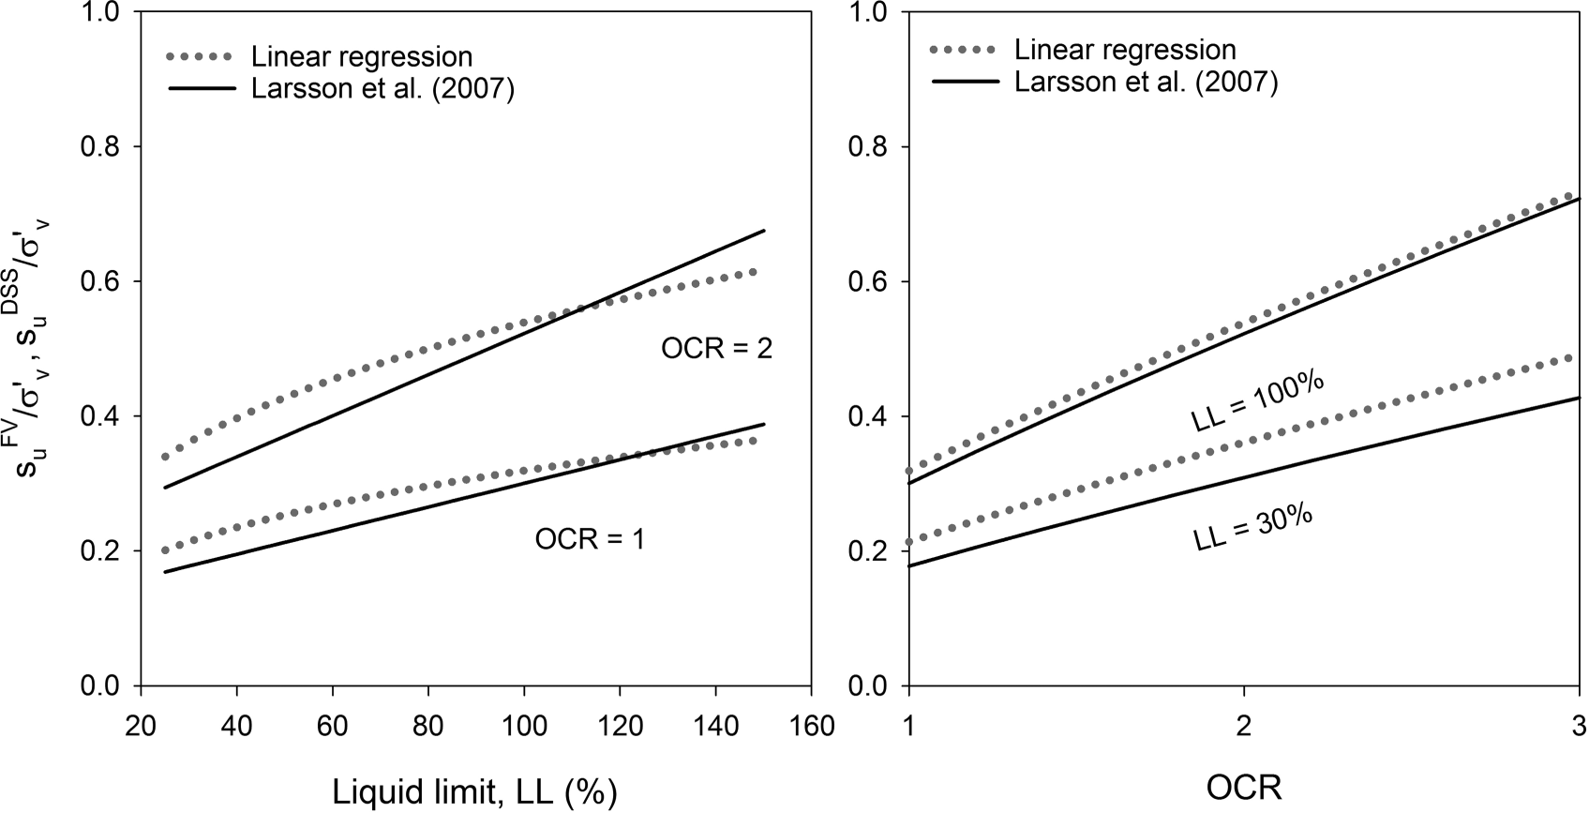

**Fig. 14.** Comparison between OCR–(*s*FV/*Cl* )–*w* for Finnish clays and OCR–(*s*DSS/*Cl* )–*w* model by Karlsrud and Hernandez-Martinez (2013) for

u v u v

Norwegian clays.

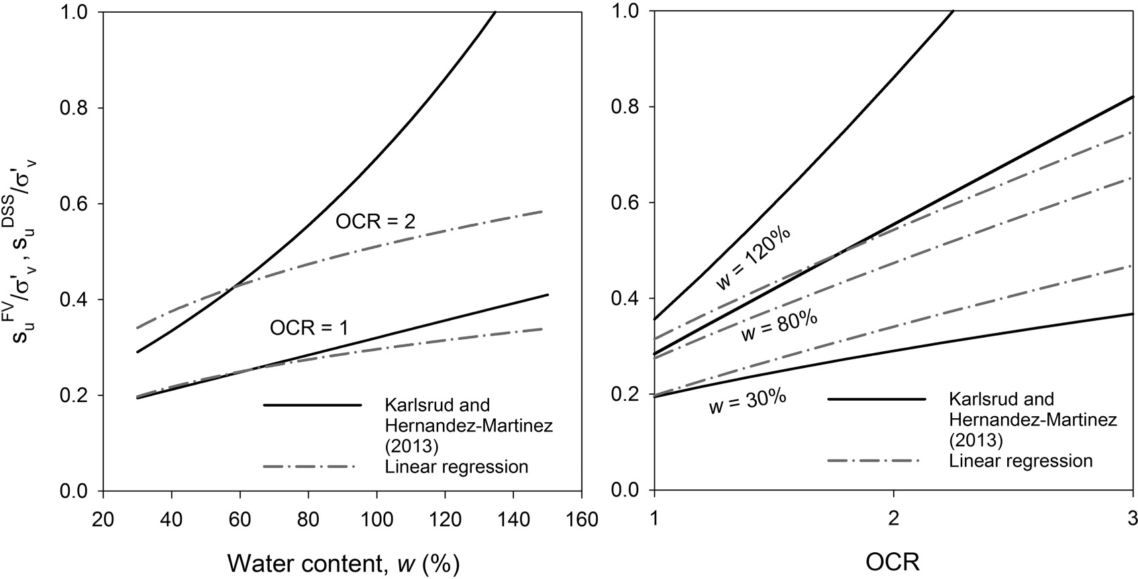

## Validation of the new transformation models

It is apparent from Table 9 that the OCR–(*s*FV/*Cl* )–*Yj* transforma-

This is possibly due to the limited amount of LL > 100% data points used to derive the correlations.

u v

tion model is strongly dependent on index parameters. As earlier explained in this section, *s*DSS of Scandinavian clays exhibits a marked dependency on LL (eq. (6)) and *w* (eq. (7)). These results may be explained by the fact that both tests at laboratory scale and FV test are performed at considerably high strain rate in

u

relatively short time frames, if compared with the time scale

However, more uncertainty comes when *w* is taken as second- ary input parameter. The transformation model given by Karlsrud and Hernandez-Martinez (2013) for DSS strength tends to deviate from the mean trend suggested by F-CLAY/10/173 database (Fig. 14), intersecting the regression line and suggesting that for a certain

number of combinations of OCR and *w*, *s*DSS of Norwegian clays

needed for causing failure in situ. It is known that undrained

would result higher than *s*FV

u

of Finnish clays. One possible reason

u

failure of e.g., embankments may take several days (La Rochelle et al. 1974), while DSS and FV tests are performed on time scales in the order of hours or minutes, respectively. While TXC, TXE, DSS tests are normally performed at a strain rate of about 1%·h−1, FV

test is executed at strain rates typically 50–60 times larger (i.e.,

that could justify the differences between the two models could be that (*i*) eq. (6) is based only on a limited number of DSS tests (as reported by Karlsrud and Hernandez-Martinez 2013) and (*ii*) *w* of the tested specimens was about 25%~80%, while the new OCR–

(*s*FV/*Cl* )–*w* model is calibrated from a wider range of *w* (*w* = 25%–

u v

60%·h−1, Ching et al. 2013). This is well reﬂected in Fig. 13 and

Fig. 14, where the OCR–(*s*FV/*Cl* )–*Yj* transformation model is com-

150%). Hence, attention must be paid when using eq. (7), as, based on this study, consistency was found only for *w* < 60%.

u v FV

FV *l*

pared to eq. (6) and eq. (7). From Fig. 13, it can be noticed how *s*u /

[Can. Geotech. J. Downloaded from www.nrcresearchpress.com](http://www.nrcresearchpress.com/) by Auchmuty Library on 04/15/17 For personal use only.

*Cl*v is generally greater than *s*DSS/*Cl* , except for LL > 100% at OCR = 1.

u

v

Figure 15 compares the variation of *s*u /*C*v with OCR for various

LL ranges. It is noticeable that for Finnish sensitive clays, the trend

**Fig. 15.** Comparison between measured (calibration and validation) data and OCR–(*s*FV/*Cl* )–LL model for Finnish clays for various LL ranges:

u v

(*a*) LL ≤ 50%; (*b*) 50% < LL ≤ 75%; (*c*) 75% < LL ≤ 100%; (*d*) LL > 100%.

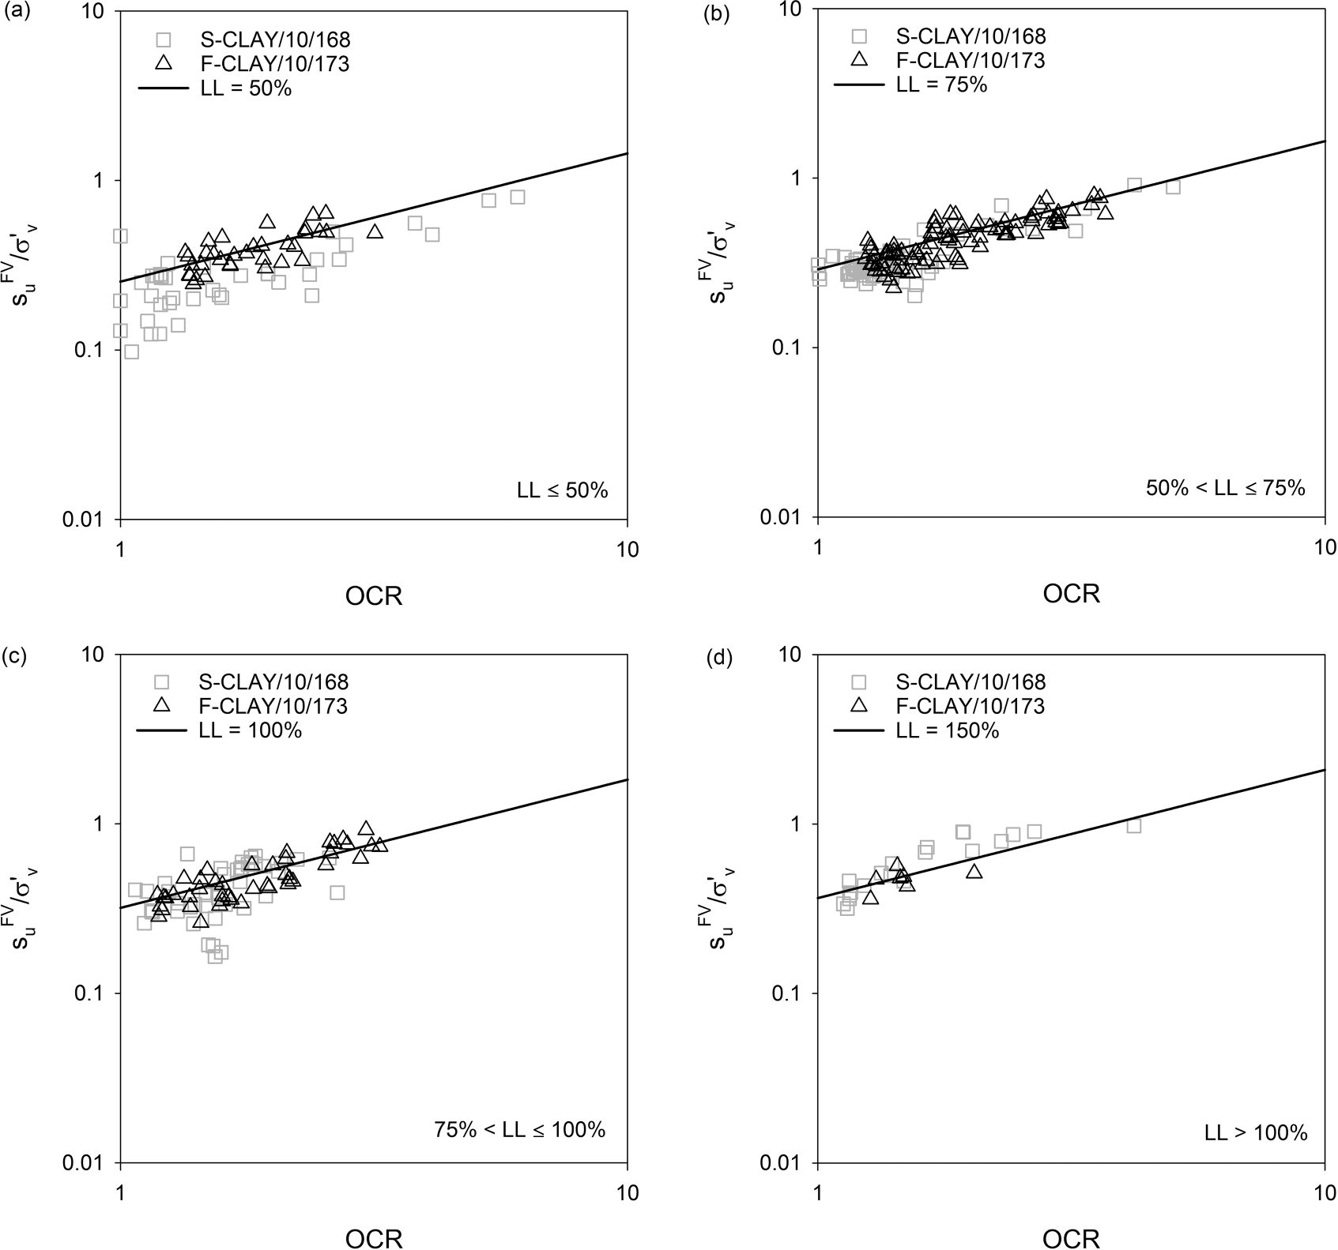

**Table 10.** Transformation models for Finnish clays and their calibration results for S-CLAY/10/168.

t

|  |  |  |  |  |
| --- | --- | --- | --- | --- |
| Calibration results | | | | |
| Relationship | *n* | Transformation model | Bias factor, *b* | COV of e = *o* |
| OCR–[*s*u(mob)/*C*v*l* ]–PI | 168 | *s*u(mob)/*C*v*l* ≈ 0.242OCR0.763PI−0.013 | 0.94 | 0.26 |
| OCR–[*s*u(mob)/*C*v*l* ]–LL | 168 | *s*u(mob)/*C*v*l* ≈ 0.245OCR0.760LL−0.005 | 0.94 | 0.25 |
| OCR–[*s*u(mob)/*C*v*l* ]–*w* | 168 | *s*u(mob)/*C*v*l* ≈ 0.246OCR0.760*w*0.027 | 0.94 | 0.25 |
| OCR–[*s*u(mob)/*C*v*l* ]–LI | 168 | *s*u(mob)/*C*v*l* ≈ 0.241OCR0.770LI0.045 | 0.95 | 0.26 |
| OCR–[*s*u(mob)/*C*v*l* ]–*S*t | 59 | *s*u(mob)/*C*v*l* ≈ 0.242OCR0.762*S*0.006 | 0.90 | 0.34 |
| OCR–(*s*FV/*Cl* )–PI | 168 | *s*FV/*Cl* ≈ 0.328OCR0.756PI0.165 | 0.95 | 0.29 |
| OCR–(*s*FV/*Cl* )–LL | 168 | *s*FV/*Cl* ≈ 0.319OCR0.757LL0.333 | 0.94 | 0.26 |
| OCR–(*s*FV/*Cl* )–*w* | 168 | *s*FV/*Cl* ≈ 0.296OCR0.788*w*0.337 | 0.97 | 0.27 |
| OCR–(*s*FV/*Cl* )–LI | 168 | *s*FV/*Cl* ≈ 0.281OCR0.770LI−0.088 | 0.95 | 0.33 |
| OCR–(*s*FV/*Cl* )–*S*t | 59 | *s*FV/*Cl* ≈ 0.280OCR0.786*S*—0.013*S*t | 0.91 | 0.44 |

u v u v

u v u v

u v u v

u v u v

u v u v t

lines (solid lines) for given values of LL move gently upwards for increasing LL. The suggested trends appear to agree with the points from the S-CLAY/10/168 database, grouped following the LL ranges adopted.

navian clays. *b* and *o* of the new correlations are summarized in Table 10. Calculated *b* values range between 0.94 and 0.97 when

the effect of PI, LL, *w*, and LI is considered, with COV values lower

than 0.30. Exception is only made for the OCR–(*s*FV/*Cl* )–LI model

u v

## Bias and uncertainties of the new transformation models

Bias factor (*b*) and coefﬁcient of variation of e (*o*) are evaluated

for the newly derived transformation models for *s* of Finnish soft

which shows COV = 0.33. Therefore, the proposed correlations can be considered almost “unbiased” with respect to S-CLAY/10/168

database. The OCR–(*s*FV/*Cl*v)–*S*t and OCR–[*s*u(mob)/*Cl* ]–*S*t models are

u u v

[Can. Geotech. J. Downloaded from www.nrcresearchpress.com](http://www.nrcresearchpress.com/) by Auchmuty Library on 04/15/17 For personal use only.

clays, through the independent S-CLAY/10/168 database of Scandi- characterized by the lowest bias factors (0.91 and 0.90, respec-

tively) and by the highest coefﬁcients of variation *o* (0.44 and 0.34, respectively). One possible reason could be that *b* and *o* of the models where *S*t is the secondary input parameter are calculated

from a lower number of data points (*n* = 59) than for the other models (*n* = 168).

The new correlation equations appear to be less “biased” than the existing type C and type D transformation models presented in Table 6. In particular, *s*FV evaluated using the new equations

u

would result less “biased” (*b* ~ 1) than from type D models of Table 6, with o values lower than 0.3 (Table 10) versus *o* = 0.35–0.43 (Table 6). In addition, equations for *s*u(mob) from Table 10 provide an almost unbiased prediction with coefﬁcient of variation (*o*) as low as 0.25.

# Discussion

Based on the results presented in Table 9, a correct evaluation of *C*p*l* would be of great importance for assessing *s*u of Finnish soft clays when direct measurements are not available. The transfor-

mation models derived in this study can predict *s*u with relatively low uncertainty, provided that OCR (primary input parameter) and a secondary input parameter (e.g., index parameter) are care- fully chosen. The usability of the new models is straightforward, as only little information is required. For instance, simple tests such as oedometer and index tests would provide sufﬁcient infor- mation for using the new models speciﬁc to Finnish clays. More- over, the evaluation of a secondary input parameter may not be required, as *s*u(mob) was observed to mainly depend on OCR (eq. (11)).

The transformation models presented in this study may also serve as a practical engineering tool for preliminary short-term analyses and (or) as a framework for validation of site-speciﬁc measurements that are suspected to be unreliable.

# Conclusions

In this study, a calibration database of multivariate clay data points from Finland is compiled for the ﬁrst time, for the scope of providing correlations for undrained shear strength (*s*u) of Finnish clays and evaluating the dependency of *s*u on the overconsolida- tion ratio (OCR), natural water content (*w*), liquid limit (LL), plas- ticity index (PI), liquidity index (LI), and sensitivity (*S*t). The new transformation models are derived through linear regression analyses.

According to the results presented in this paper, a mutual de-

pendence between the uncorrected *s*u from FV test (*s*FV), OCR, and

# References

Bjerrum, L. 1954. Geotechnical properties of Norwegian marine clays. Géotech- nique, **4**(2): 49–69. doi:[10.1680/geot.1954.4.2.49](http://dx.doi.org/10.1680/geot.1954.4.2.49).

Bjerrum, L. 1972. Embankments on soft ground. *In* Proceedings of the ASCE Specialty Conference on Performance of Earth and Earth-Supported Struc- tures, Purdue University, Lafayette, Ind. ASCE. Vol. 2, pp. 1–54.

Chandler, R.J. 1988. The in-situ measurement of the undrained shear strength of clays using the ﬁeld vane. *In* Vane shear strength testing in soils: ﬁeld and laboratory studies. ASTM STP 1014. ASTM, Philadelphia, Pa. pp. 13–44.

Ching, J., and Phoon, K.-K. 2012*a*. Modeling parameters of structured clays as a multivariate normal distribution. Canadian Geotechnical Journal, **49**(5): 522–545. doi:[10.1139/t2012-015](http://dx.doi.org/10.1139/t2012-015).

Ching, J., and Phoon, K.-K. 2012*b*. Establishment of generic transformations for geotechnical design parameters. Structural Safety, **35**: 52–62. doi:[10.1016/j.](http://dx.doi.org/10.1016/j.strusafe.2011.12.003) [strusafe.2011.12.003](http://dx.doi.org/10.1016/j.strusafe.2011.12.003).

Ching, J., and Phoon, K.-K. 2013. Multivariate distribution for undrained shear strengths under various test procedures. Canadian Geotechnical Journal, **50**(9): 907–923. doi:[10.1139/cgj-2013-0002](http://dx.doi.org/10.1139/cgj-2013-0002).

Ching, J., and Phoon, K.-K. 2014*a*. Transformations and correlations among some clay parameters — the global database. Canadian Geotechnical Journal, **51**(6): 663–685. doi:[10.1139/cgj-2013-0262](http://dx.doi.org/10.1139/cgj-2013-0262).

Ching, J., and Phoon, K.-K. 2014*b*. Correlations among some clay parameters - the multivariate distribution. Canadian Geotechnical Journal, **51**(6): 686–704. doi:[10.1139/cgj-2013-0353](http://dx.doi.org/10.1139/cgj-2013-0353).

Ching, J., Phoon, K.-K., and Chen, Y.-C. 2010. Reducing shear strength uncertain- ties in clays by multivariate correlations. Canadian Geotechnical Journal, **47**(1): 16–33. doi:[10.1139/T09-074](http://dx.doi.org/10.1139/T09-074).

Ching, J., Phoon, K.-K., and Lee, W.T. 2013. Second-moment characterization of undrained shear strengths from different test procedures. *In* Proceedings, Foundation Engineering in the Face of Uncertainty: Honoring Professor

F.H. Kulhawy. Geotechnical Special Publication 229. ASCE, Reston, Va. pp. 308–320.

Ching, J., Phoon, K.-K., and Chen, C.-H. 2014. Modeling piezocone cone penetra- tion (CPTU) parameters of clays as a multivariate normal distribution. Cana- dian Geotechnical Journal, **51**(1): 77–91. doi:[10.1139/cgj-2012-0259](http://dx.doi.org/10.1139/cgj-2012-0259).

D’Ignazio, M., Di Buò, B., and Länsivaara, T. 2015. A study on the behavior of weathered clay crust in the Perniö failure test. *In* Proceedings of XVI ECSMGE, Edinburgh, Scotland, 13–17 September 2015. Vol. 7, pp. 3639–3644

Gardemeister, R. 1973. Hienorakenteisen maalajien geologisia ja geoteknisiä tutkimustuloksia. Geotekniikan laboratorio, Report n.8. VTT Offsetpaino. Otaniemi, Helsinki, Finland. ISBN 951-38-0046-6.

Hansbo, S. 1957. A new approach to the determination of the shear strength of clay by the fall-cone test. Royal Swedish Geotechnical Institute.

Hoikkala, S. 1991. Continuous and incremental loading oedometer tests. M.Sc. thesis, Helsinki University of Technology, Espoo, Finland. [In Finnish.]

Jaky, J. 1944. The coefﬁcient of earth pressure at rest. Journal of the Society of Hungarian Architects and Engineers, **78**(22): 355–358.

Jamiolkowski, M., Ladd, C.C., Germain, J.T., and Lancellotta, R. 1985. New devel- opments in ﬁeld and laboratory testing of soils. *In* Proceedings of the 11th International Conference on Soil Mechanics and Foundation Engineering, San Francisco. Vol. 1, pp. 57–153.

Karlsrud, K., and Hernandez-Martinez, F.G. 2013. Strength and deformation properties of Norwegian clays from laboratory tests on high-quality block samples. Canadian Geotechnical Journal, **50**(12): 1273–1293. doi:[10.1139/cgj-](http://dx.doi.org/10.1139/cgj-2013-0298) [2013-0298](http://dx.doi.org/10.1139/cgj-2013-0298).

index parameters (PI, LL, *w,*

u

and LI) exists. The only exception is

Kolisoja, P., Sahi, K., and Hartikainen, J. 1989. An automatic triaxial-oedometer device. *In* Proceedings of the 12th International Conference on Soil Mechan-

observed for *S*t, which seems to have a negligible inﬂuence on *s*FV.

[Can. Geotech. J. Downloaded from www.nrcresearchpress.com](http://www.nrcresearchpress.com/) by Auchmuty Library on 04/15/17 For personal use only.

u

On the contrary, the mobilized undrained shear strength *s*u(mob) seems to be mainly dependent on OCR and not signiﬁcantly af- fected by index parameters.

Another independent clay database of Scandinavian clays is compiled to validate the new equations. Consistency of the new transformation models is checked by (*i*) evaluating bias factors and coefﬁcients of variation associated with the validation data- base and (*ii*) comparison with existing transformation models for undrained shear strength of Swedish and Norwegian clays. Con- sistency is clearly revealed by the validation process. In particular, the new transformation models result in overall less biased than the existing ones, showing coefﬁcients of variation lower than 0.30.

# Acknowledgements

The authors acknowledge Matteo Maggioni, from the Depart- ment of Electrical and Electronic Engineering at Imperial College of London for his support with the regression analyses presented in this work. A special thank you is also given to the reviewers for their helpful comments on the manuscript.

ics and Foundation Engineering. pp. 61–64.

Kulhawy, F.H., and Mayne, P.W. 1990. Manual on estimating soil properties for foundation design (No. EPRI-EL-6800). *Prepared by* Cornell University Geotech- nical Engineering Group, Ithaca, New York, for Electric Power Research Institute, Palo Alto, Calif.

La Rochelle, P., Trak, B., Tavenas, F., and Roy, M. 1974. Failure of a test embank- ment on a sensitive Champlain clay deposit. Canadian Geotechnical Journal, **11**(1): 142–164. doi:[10.1139/t74-009](http://dx.doi.org/10.1139/t74-009).

Ladd, C.C., and Foott, R. 1974. New design procedure for stability of soft clays.

Journal of the Geotechnical Engineering Division, ASCE, **100**(7): 763–786.

Länsivaara, T. 1999. A study of the mechanical behavior of soft clay. Ph.D. thesis, Norwegian University of Science and Technology, Trondheim.

Larsson, R. 1980. Undrained shear strength in stability calculation of embank- ments and foundations on soft clays. Canadian Geotechnical Journal, **17**(4): 591–602. doi:[10.1139/t80-066](http://dx.doi.org/10.1139/t80-066).

Larsson, R., and Mulabdic, M. 1991. Piezocone tests in clay. Swedish Geotechnical Institute, Linköping, Sweden. Report No. 42.

Larsson, R., Sällfors, G., Bengtsson, P.E., Alén, C., Bergdahl, U, and Eriksson, L. 2007. Skjuvhällfasthet: utvärdering I kohesionsjord. 2nd ed. Information 3, Swedish Geotechnical Institute (SGI), Linköping, Sweden.

Lefebvre, G., Paré, J.-J., and Dascal, O. 1987. Undrained shear strength in the surﬁcial weathered crust. Canadian Geotechnical Journal, **24**(1): 23–34. doi: [10.1139/t87-003](http://dx.doi.org/10.1139/t87-003).

Lehtonen, V., Meehan, C., Länsivaara, T., and Mansikkamäki, J. 2015. Full-scale embankment failure test under simulated train loading. Géotechnique, **65**(12): 961–974. doi:[10.1680/jgeot.14.P.100](http://dx.doi.org/10.1680/jgeot.14.P.100).

Leroueil, S. 1988. Tenth Canadian Geotechnical Colloquium: Recent develop- ments in consolidation of natural clays. Canadian Geotechnical Journal,  **25**(1): 85–107. doi:[10.1139/t88-010](http://dx.doi.org/10.1139/t88-010).

Leroueil, S. 1996. Compressibility of clays: fundamental and practical aspects. Journal of Geotechnical Engineering, **122**(7): 534–543. doi:[10.1061/(ASCE)0733-](http://dx.doi.org/10.1061/(ASCE)0733-9410(1996)122%3A7(534)) [9410(1996)122:7(534)](http://dx.doi.org/10.1061/(ASCE)0733-9410(1996)122%3A7(534)).

Wroth, C.P., and Wood, D.M. 1978. The correlation of index properties with some basic engineering properties of soils. Canadian Geotechnical Journal, **15**(2): 137–145. doi:[10.1139/t78-014](http://dx.doi.org/10.1139/t78-014).

# List of symbols

Leroueil, S., and Soares Marques, M.E. 1996. Importance of strain rate and tem-

1. pore pressure ratio [= (*u*

– *u* )/(*q* – *C* )]

perature effects in geotechnical engineering. *In* Measuring and modeling time dependent soil behavior. *Edited by* T.C. Sheahan and V.N. Kaliakin.

q

*b* bias factor

2 0 t v

Geotechnical Special Publication No. 61. American Society of Civil Engineers (ASCE), New York, USA. pp. 1–60.

Leroueil, S., Samson, L., and Bozozuk, M. 1983. Laboratory and ﬁeld determina- tion of preconsolidation pressures at Gloucester. Canadian Geotechnical Journal, **20**(3): 477–490. doi:[10.1139/t83-056](http://dx.doi.org/10.1139/t83-056).

Leroueil, S., Kabbaj, M., Tavenas, F., and Bouchard, R. 1985. Stress–strain–strain rate relation for the compressibility of sensitive natural clays. Géotechnique, **35**(2): 159–180. doi:[10.1680/geot.1985.35.2.159](http://dx.doi.org/10.1680/geot.1985.35.2.159).

Locat, J., and Demers, D. 1988. Viscosity, yield stress, remolded strength, and liquidity index relationships for sensitive clays. Canadian Geotechnical Jour- nal, **25**(4): 799–806.

Mansikkamäki, J. 2015. Effective stress ﬁnite element stability analysis of an old railway embankment on soft clay. Ph.D. thesis, Tampere University of Tech- nology, Tampere.

MathWorks. 1995. MATLAB, user’s manual. The MathWorks, Inc., Natick, Mass. Mesri, G. 1975. Discussion on “New design procedure for stability of soft clays”.

Journal of the Geotechnical Engineering Division, ASCE, **101**(4): 409–412. Mesri, G. 1989. A re-evaluation of *s*u(mob) = 0.22 *C*p*l* using laboratory shear tests.

*C*c compression index of clay

*C*s swelling index of clay COV coefﬁcient of variation

*F* multivariable function

*K*0 earth pressure coefﬁcient at rest from Jaky’s formula LI liquidity index [= (*w* – PL)/(LL – PL)]

LL liquid limit

*m* SHANSEP exponent

OCR overconsolidation ratio (= *C*p*l* /*C*v*l* )

*P*a atmospheric pressure (= 101.3 kPa)

PI plasticity index (= LL – PL)

PL plastic limit

*q*t cone tip resistance

(*q*t – Cv)/*C*v*l* normalized cone tip resistance (*q*t – *u*2)/*C*v*l* effective cone tip resistance

*S* normalized *s*u for normally consolidated state

*S*t sensitivity (= *s* /*s*re)

Canadian Geotechnical Journal, **26**(1): 162–164. doi:[10.1139/t89-017](http://dx.doi.org/10.1139/t89-017). *s* u u

Mesri, G., and Huvaj, N. 2007. Shear strength mobilized in undrained failure of soft clay and silt deposits. *In* Advances in measurement and modeling of soil

u undrained shear strength

*s*u(mob) mobilized undrained shear strength (= *入 s*FV)

u

*s*CIUC *s*

behaviour. GSP 173. *Edited by* D.J. DeGroot et al. ASCE. pp. 1–22.

Müller, R. 2013. Probabilistic stability analysis of embankments founded on clay.

Ph.D. thesis, Royal Institute of Technology (KTH), Stockholm.

Müller, R., Larsson, S., and Spross, J. 2014. Extended multivariate approach for uncertainty reduction in the assessment of undrained shear strength in clays. Canadian Geotechnical Journal, **51**(3): 231–245. doi:[10.1139/cgj-2012-](http://dx.doi.org/10.1139/cgj-2012-0176) [0176](http://dx.doi.org/10.1139/cgj-2012-0176).

Müller, R., Larsson, S., and Spross, J. 2016. Multivariate stability assessment during staged construction. Canadian Geotechnical Journal, **53**(4): 603–618. doi:[10.1139/cgj-2015-0037](http://dx.doi.org/10.1139/cgj-2015-0037).

Phoon, K.-K., and Kulhawy, F.H. 1999. Characterization of geotechnical variabil- ity. Canadian Geotechnical Journal, **36**(4): 612–624. doi:[10.1139/t99-038](http://dx.doi.org/10.1139/t99-038).

Prästings, A., Larsson, S., and Müller, R. 2016. Multivariate approach in reliability- based design of a sheet pile wall. Transportation Geotechnics, **7**: 1–12. doi:[10.](http://dx.doi.org/10.1016/j.trgeo.2016.03.001) [1016/j.trgeo.2016.03.001](http://dx.doi.org/10.1016/j.trgeo.2016.03.001).

Rankka, K., Andersson-Sköld, Y., Hultén, C., Larsson, R., Leroux, V., and Dahlin,

T. 2004. Quick clay in Sweden. Swedish Geotechnical Institute, Linkoping, Sweden. Report No. 65.

Ratahallintokeskus. 2005. Radan stabiliteetin laskenta, olemassa olevat penker- eet. Ratahallintokeskuksen julkaisuja B15, Ratahallintokeskus, Helsinki. [In Finnish. In English: Guidelines for embankments stability calculation by the Finnish Transport Agency, publication B15.]

Rosenqvist, I.T. 1953. Considerations on the sensitivity of Norwegian quick-clays.

Géotechnique, **3**(5): 195–200. doi:[10.1680/geot.1953.3.5.195](http://dx.doi.org/10.1680/geot.1953.3.5.195).

Rosenqvist, I.T. 1966. Norwegian research into the properties of quick clay-a review. Engineering Geology, **1**(6): 445–450. doi:[10.1016/0013-7952(66)90020-2](http://dx.doi.org/10.1016/0013-7952(66)90020-2).

Schoﬁeld, A.N., and Wroth, C.P. 1968. Critical state soil mechanics. McGraw-Hill,

u u from isotropically consolidated undrained compres-

sion test

*s*CK0UC *s*u from *K*0-consolidated undrained compression test

u

*s*CK0UE *s*u from *K*0-consolidated undrained extension test

u

*s*DSS undrained shear strength from direct simple shear test

uFV

*s*u undrained shear strength measured from ﬁeld vane test

*s*re remolded undrained shear strength

u

*s*UC *s*u from unconﬁned compression test

u

*s*UU *s*u from unconsolidated undrained compression test

u

*u*0 hydrostatic pore pressure

*u*2 pore pressure acting behind the cone

*Yj* secondary input parameter

*w* natural water content

*a* scalar coefﬁcient in the multivariable function *F*

*�* scalar coefﬁcient in the multivariable function *F*

*'Y* scalar coefﬁcient in the multivariable function *F*

*o* coefﬁcient of variation of e e variability term

*入* correction factor for *s*FV based on plasticity

u

1. standard deviation of *s*u(mob)/*C*v*l*

*C*v vertical stress

*C*v*l* effective vertical stress

*C*p*l* vertical preconsolidation pressure

London, UK.

Skempton, A.W. 1954. Discussion of the structure of inorganic soil. Journal of

*C*p*l* CRS

*C*p*l* IL

vertical preconsolidation pressure from CRS test vertical preconsolidation pressure from IL test

American Society of Civil Engineers, **80**(478): 19–22.

[Can. Geotech. J. Downloaded from www.nrcresearchpress.com](http://www.nrcresearchpress.com/) by Auchmuty Library on 04/15/17 For personal use only.

Tanaka, H., Hirabayashi, H., Matsuoka, T., and Kaneko, H. 2012. Use of fall cone test as measurement of shear strength for soft clay materials. Soils and Foundations, **52**(4): 590–599. doi:[10.1016/j.sandf.2012.07.002](http://dx.doi.org/10.1016/j.sandf.2012.07.002).

Westerberg, B., Müller, R., and Larsson, S. 2015. Evaluation of undrained shear strength of Swedish ﬁne-grained sulphide soils. Engineering Geology, **188**: 77–87. doi:[10.1016/j.enggeo.2015.01.007](http://dx.doi.org/10.1016/j.enggeo.2015.01.007).

*T*0 initially mobilized shear stress

*cp l* effective friction angle of soil

# Appendix A. Multivariate clay databases

Appendix Tables A1–A2 appear on the following pages.

**Table A1.** Basic information of the F-CLAY/7/216 database: *C*p*l* data points from IL oedometer test.

**Table A1** (*continued*).

Depth *s*FV *Cl Cl* PL

Depth *s*FV

u

*C*v*l*

*C*p*l* PL

Location

(m)

u

(kPa)

v

(kPa)

p

(kPa) LL (%) (%)

*w* (%) *S*t

|  |  |  |  |  |  |  |  |  |  |  |  |  |  |  |  |  |  |  |
| --- | --- | --- | --- | --- | --- | --- | --- | --- | --- | --- | --- | --- | --- | --- | --- | --- | --- | --- |
| Location | (m) | (kPa) | (kPa) | (kPa) | LL (%) | (%) | *w* (%) | *S*t |  | Perniö (location 1)* | 2.2 | 9.30 | 28.9 | 74.3 | 79.0 | 32.0 | 75.0 | 14.0 |
| Espoo, Kaukalahti | 3.2 | 13.0 | 30.2 | 43.0 | 70.0 | 25.0 | 85.0 | 11.0 |  |  | 2.7 | 10.20 | 31.4 | 62.6 | 74.0 | 32.0 | 78.5 | 18.6 |
|  | 4.6 | 7.0 | 38.6 | 60.0 | 60.0 | 25.0 | 75.0 | 11.0 |  |  | 2.6 | 12.20 | 31.0 | 64.7 | 75.0 | 32.0 | 80.8 | 19.1 |
|  | 5.2 | 7.5 | 42.2 | 45.0 | 45.0 | 20.0 | 50.0 | 10.0 |  |  | 2.7 | 13.60 | 31.6 | 61.5 | 82.0 | 32.0 | 97.6 | 22.9 |
| Espoo, Martinkylä | 5.5 | 7.0 | 24.5 | 25.0 | 70.0 | 20.0 | 80.0 | 4.0 |  |  | 2.1 | 19.10 | 28.5 | 73.8 | 76.0 | 32.0 | 88.0 | 25.2 |
|  | 6.0 | 7.0 | 27.0 | 30.0 | 30.0 | 15.0 | 75.0 | 2.0 |  |  | 5.1 | 12.80 | 43.5 | 61.5 | 65.0 | 32.0 | 80.1 | 30.7 |
|  | 7.0 | 12.0 | 32.0 | 40.0 | 80.0 | 20.0 | 100.0 | 6.0 |  |  | 3.1 | 9.30 | 33.5 | 51.5 | 65.0 | 32.0 | 83.0 | 32.0 |
|  | 8.0 | 12.0 | 37.0 | 40.0 | 90.0 | 15.0 | 120.0 | 5.0 |  |  | 2.2 | 18.60 | 29.1 | 73.9 | 46.0 | 32.0 | 61.7 | 32.7 |
| Helsinki, Malmi | 3.0 | 9.0 | 18.0 | 30.0 | 80.0 | 35.0 | 110.0 | 12.0 |  |  | 5.7 | 11.60 | 46.4 | 64.4 | 58.0 | 32.0 | 80.9 | 33.7 |
|  | 4.0 | 11.0 | 23.0 | 35.0 | 75.0 | 30.0 | 100.0 | 10.0 |  |  | 3.6 | 9.90 | 36.0 | 54.0 | 63.0 | 32.0 | 86.0 | 35.0 |
|  | 5.0 | 10.0 | 28.0 | 30.0 | 43.0 | 20.0 | 65.0 | 10.0 |  |  | 4.2 | 12.80 | 39.1 | 57.1 | 64.0 | 32.0 | 90.0 | 35.5 |
|  | 6.0 | 11.0 | 33.0 | 40.0 | 55.0 | 20.0 | 80.0 | 11.0 |  |  | 5.2 | 15.40 | 44.1 | 62.1 | 64.0 | 32.0 | 70.9 | 35.6 |
|  | 7.0 | 8.0 | 38.0 | 50.0 | 25.0 | 20.0 | 40.0 | 9.0 |  |  | 6.1 | 13.30 | 48.5 | 66.5 | 38.0 | 32.0 | 47.9 | 36.7 |
|  | 8.0 | 16.0 | 43.0 | 50.0 | 22.0 | 20.0 | 25.0 | 13.0 |  |  | 4.7 | 14.80 | 41.6 | 59.6 | 55.0 | 32.0 | 88.2 | 37.4 |
| Kouvola | 1.5 | 42.0 | 24.2 | 150.0 | 45.0 | 20.0 | 40.0 | 6.5 |  |  | 3.2 | 11.30 | 33.9 | 51.9 | 60.0 | 32.0 | 82.3 | 39.1 |
|  | 3.0 | 15.0 | 33.0 | 40.0 | 80.0 | 25.0 | 100.0 | 11.0 |  |  | 3.7 | 6.40 | 36.4 | 54.4 | 51.0 | 32.0 | 77.5 | 39.4 |
|  | 5.0 | 21.0 | 43.0 | 50.0 | 110.0 | 25.0 | 130.0 | 8.0 |  |  | 4.6 | 10.70 | 41.0 | 59.0 | 76.0 | 32.0 | 96.6 | 41.3 |
|  | 6.0 | 23.0 | 48.0 | 55.0 | 110.0 | 25.0 | 120.0 | 8.0 |  |  | 4.7 | 11.60 | 41.4 | 59.4 | 51.0 | 32.0 | 72.6 | 45.7 |
|  | 7.0 | 25.0 | 53.0 | 60.0 | 80.0 | 25.0 | 110.0 | 7.0 |  |  | 4.1 | 10.40 | 38.5 | 56.5 | 50.0 | 32.0 | 69.6 | 45.7 |
| Kurkela* | 2.2 | 19.1 | 35.4 | 105.4 | 69.0 | 32.3 | 75.0 | 40.0 |  |  | 3.7 | 16.00 | 36.6 | 54.6 | 50.0 | 32.0 | 74.4 | 46.3 |
|  | 2.7 | 20.0 | 37.8 | 107.8 | 66.3 | 31.6 | 79.0 | 39.5 |  |  | 5.2 | 9.90 | 43.9 | 61.9 | 59.0 | 32.0 | 84.1 | 46.5 |
|  | 3.2 | 28.2 | 40.3 | 110.3 | 60.8 | 30.2 | 70.0 | 39.0 |  |  | 3.2 | 12.50 | 34.1 | 52.1 | 45.0 | 32.0 | 70.6 | 49.4 |
|  | 3.7 | 25.0 | 42.7 | 112.4 | 55.2 | 28.8 | 62.0 | 38.5 |  |  | 5.7 | 16.80 | 46.6 | 64.6 | 54.0 | 32.0 | 80.1 | 51.1 |
|  | 4.2 | 22.3 | 45.2 | 115.2 | 49.7 | 27.4 | 56.7 | 37.0 |  |  | 4.2 | 11.30 | 38.9 | 56.9 | 51.0 | 32.0 | 72.0 | 51.3 |
|  | 4.7 | 23.7 | 47.6 | 117.6 | 48.8 | 27.2 | 60.0 | 35.0 |  |  | 5.6 | 11.30 | 46.0 | 64.0 | 50.0 | 32.0 | 75.9 | 57.7 |
|  | 5.2 | 31.3 | 50.1 | 120.1 | 48.5 | 27.1 | 65.3 | 24.1 |  | Perniö (location 2)* | 1.5 | 38.0 | 19.0 | 64.0 | 89.9 | 36.0 | 58.9 | 64.0 |
|  | 6.2 | 28.4 | 55.0 | 127.3 | 48.0 | 27.0 | 52.1 | 24.2 |  |  | 2.5 | 10.0 | 24.2 | 44.2 | 89.9 | 36.0 | 110.0 | 58.0 |
|  | 7.2 | 27.8 | 59.9 | 140.0 | 51.8 | 28.0 | 53.5 | 24.0 |  |  | 3.0 | 8.7 | 26.4 | 41.4 | 86.3 | 36.0 | 104.0 | 55.5 |
|  | 8.2 | 29.9 | 64.8 | 152.3 | 55.8 | 28.9 | 55.7 | 24.0 |  |  | 3.5 | 7.5 | 28.6 | 38.6 | 71.1 | 36.0 | 94.0 | 53.5 |
|  | 9.2 | 34.9 | 69.7 | 160.0 | 68.8 | 32.2 | 65.0 | 13.5 |  |  | 4.0 | 8.7 | 30.8 | 40.8 | 60.2 | 36.0 | 84.0 | 52.3 |
|  | 10.2 | 34.1 | 74.6 | 163.0 | 82.4 | 35.6 | 77.4 | 10.0 |  |  | 4.5 | 10.0 | 33.0 | 43.0 | 58.2 | 36.0 | 75.0 | 51.4 |
|  | 11.2 | 35.1 | 79.5 | 170.0 | 94.9 | 38.7 | 82.0 | 10.5 |  |  | 5.0 | 11.0 | 35.2 | 45.2 | 54.1 | 36.0 | 80.0 | 50.4 |
|  | 12.2 | 23.3 | 84.4 | 182.3 | 107.3 | 41.8 | 87.7 | 10.5 |  |  | 5.5 | 15.0 | 37.4 | 47.4 | 50.4 | 36.0 | 75.0 | 47.5 |
|  | 13.2 | 21.1 | 89.3 | 185.0 | 111.8 | 42.9 | 83.9 | 10.0 |  |  | 6.0 | 17.0 | 39.6 | 49.6 | 52.0 | 36.0 | 80.0 | 43.8 |
| Loimaa | 3.0 | 20.0 | 24.0 | 48.0 | 55.0 | 25.0 | 65.0 | 11.0 |  |  | 6.5 | 14.0 | 41.8 | 51.8 | 66.9 | 36.0 | 92.0 | 39.2 |
|  | 4.0 | 19.0 | 31.0 | 90.0 | 51.0 | 23.0 | 60.0 | 9.0 |  |  | 7.0 | 16.0 | 44.0 | 54.0 | 75.5 | 36.0 | 84.0 | 39.5 |
|  | 5.0 | 18.0 | 38.0 | 50.0 | 75.0 | 23.0 | 70.0 | 7.0 |  |  | 7.5 | 17.0 | 46.2 | 56.2 | 75.9 | 36.0 | 88.0 | 40.0 |
|  | 7.0 | 24.0 | 52.0 | 65.0 | 48.0 | 23.0 | 65.0 | 9.0 |  |  | 8.0 | 15.0 | 48.4 | 58.4 | 76.3 | 36.0 | 87.0 | 40.0 |
|  | 8.0 | 24.0 | 59.0 | 85.0 | 47.0 | 23.0 | 70.0 | 13.0 |  |  | 8.5 | 16.5 | 50.6 | 60.6 | 76.7 | 36.0 | 86.0 | 45.0 |
|  | 9.0 | 23.0 | 66.0 | 67.0 | 55.0 | 25.0 | 70.0 | 13.0 |  |  | 9.0 | 15.0 | 52.8 | 62.8 | 77.2 | 36.0 | 88.0 | 45.0 |
|  | 10.0 | 25.0 | 73.0 | 110.0 | 49.0 | 23.0 | 60.0 | 9.0 |  |  | 9.5 | 21.0 | 55.0 | 65.0 | 77.2 | 36.0 | 85.0 | 40.0 |
|  | 11.0 | 25.0 | 80.0 | 120.0 | 51.0 | 23.0 | 60.0 | 8.0 |  |  | 2.0 | 13.0 | 21.5 | 45.0 | 75.0 | 25.0 | 75.0 | 11.0 |
|  | 12.0 | 27.0 | 87.0 | 110.0 | 55.0 | 23.0 | 57.0 | 7.0 |  |  | 3.0 | 10.0 | 27.0 | 30.0 | 75.0 | 30.0 | 75.0 | 20.0 |
|  | 13.0 | 27.0 | 94.0 | 100.0 | 52.0 | 22.0 | 65.0 | 8.0 |  |  | 5.0 | 16.0 | 38.0 | 60.0 | 51.0 | 25.0 | 75.0 | 21.0 |
| Lokalahti | 5.0 | 9.0 | 16.5 | 22.0 | 60.0 | 20.0 | 100.0 | 17.0 |  |  | 6.0 | 18.0 | 43.5 | 65.0 | 49.0 | 30.0 | 65.0 | 20.0 |
|  | 7.0 | 10.0 | 26.5 | 28.0 | 49.0 | 20.0 | 80.0 | 19.0 |  | Raisio, Autolava | 0.8 | 49.0 | 19.8 | 125.0 | 50.0 | 20.0 | 40.0 | 3.0 |
| Nurmijarvi | 2.4 | 8.0 | 15.6 | 25.0 | 120.0 | 50.0 | 150.0 | 10.0 |  |  | 1.5 | 13.0 | 18.5 | 39.0 | 70.0 | 20.0 | 70.0 | 10.0 |
|  | 3.6 | 7.0 | 20.4 | 30.0 | 52.0 | 25.0 | 75.0 | 9.0 |  |  | 2.5 | 10.0 | 24.5 | 50.0 | 70.0 | 23.0 | 90.0 | 9.0 |
|  | 6.0 | 16.0 | 30.0 | 35.0 | 80.0 | 30.0 | 120.0 | 7.0 |  |  | 3.0 | 12.0 | 27.0 | 38.0 | 75.0 | 25.0 | 90.0 | 8.0 |
|  | 7.0 | 17.0 | 34.0 | 48.0 | 75.0 | 30.0 | 100.0 | 10.0 |  |  | 4.0 | 14.0 | 32.0 | 40.0 | 100.0 | 27.0 | 130.0 | 10.0 |
|  | 8.0 | 22.0 | 38.0 | 51.0 | 75.0 | 30.0 | 100.0 | 12.0 |  | Raisio, Krookila | 2.5 | 13.0 | 26.3 | 60.0 | 85.0 | 25.0 | 87.0 | 11.0 |
|  | 9.0 | 24.0 | 42.0 | 60.0 | 90.0 | 30.0 | 100.0 | 13.0 |  |  | 3.5 | 11.0 | 30.8 | 40.0 | 80.0 | 25.0 | 90.0 | 12.0 |
|  | 10.0 | 25.0 | 46.0 | 75.0 | 75.0 | 30.0 | 90.0 | 13.0 |  |  | 4.5 | 12.0 | 35.3 | 48.0 | 85.0 | 25.0 | 80.0 | 9.0 |
|  | 11.0 | 28.0 | 53.0 | 80.0 | 65.0 | 30.0 | 75.0 | 14.0 |  |  | 5.5 | 17.0 | 39.8 | 47.0 | 125.0 | 30.0 | 130.0 | 10.0 |
|  | 13.0 | 34.0 | 67.0 | 90.0 | 60.0 | 25.0 | 58.0 | 12.0 |  |  | 6.5 | 25.0 | 44.3 | 50.0 | 120.0 | 25.0 | 120.0 | 10.0 |
|  | 14.0 | 22.0 | 74.0 | 130.0 | 65.0 | 25.0 | 60.0 | 8.0 |  |  | 7.5 | 23.0 | 48.8 | 50.0 | 110.0 | 25.0 | 110.0 | 9.0 |
|  | 16.0 | 28.0 | 88.0 | 100.0 | 40.0 | 25.0 | 35.0 | 6.0 |  |  | 8.5 | 22.0 | 53.3 | 60.0 | 100.0 | 25.0 | 95.0 | 10.0 |
|  | 17.0 | 30.0 | 95.0 | 100.0 | 52.0 | 25.0 | 60.0 | 7.0 |  |  | 9.5 | 22.0 | 57.8 | 90.0 | 100.0 | 25.0 | 95.0 | 8.0 |
|  | 18.0 | 35.0 | 102.0 | 140.0 | 70.0 | 25.0 | 55.0 | 8.0 |  |  | 10.5 | 23.0 | 62.3 | 80.0 | 85.0 | 25.0 | 80.0 | 8.0 |
| Otaniemi | 2.7 | 5.0 | 10.1 | 20.0 | 105.0 | 25.0 | 120.0 | 9.0 |  | Raisio, Ristimaki | 0.5 | 10.0 | 7.5 | 30.0 | 70.0 | 30.0 | 70.0 | 12.0 |
|  | 5.5 | 12.0 | 19.5 | 28.0 | 70.0 | 30.0 | 75.0 | 5.0 |  |  | 1.5 | 10.0 | 12.5 | 35.0 | 75.0 | 40.0 | 85.0 | 9.0 |
|  | 6.5 | 11.0 | 24.5 | 35.0 | 70.0 | 25.0 | 65.0 | 4.0 |  |  | 2.5 | 10.0 | 17.5 | 35.0 | 80.0 | 45.0 | 95.0 | 12.0 |
|  | 7.5 | 14.0 | 29.5 | 50.0 | 80.0 | 30.0 | 85.0 | 5.0 |  |  | 3.5 | 17.0 | 22.5 | 50.0 | 65.0 | 25.0 | 100.0 | 10.0 |
|  | 8.5 | 19.0 | 34.5 | 80.0 | 65.0 | 30.0 | 80.0 | 7.0 |  |  | 5.5 | 15.0 | 32.5 | 43.0 | 70.0 | 35.0 | 80.0 | 11.0 |
|  | 9.5 | 12.0 | 39.5 | 60.0 | 43.0 | 25.0 | 50.0 | 6.0 |  |  | 8.0 | 18.0 | 45.0 | 50.0 | 55.0 | 30.0 | 75.0 | 9.0 |
|  | 10.5 | 15.0 | 44.5 | 80.0 | 47.0 | 25.0 | 55.0 | 8.0 |  |  |  |  |  |  |  |  |  |  |

[Can. Geotech. J. Downloaded from www.nrcresearchpress.com](http://www.nrcresearchpress.com/) by Auchmuty Library on 04/15/17 For personal use only.

**Table A1** (*continued*).

Depth *s*FV

u

*C*v*l*

*C*p*l* PL

**Table A1** (*concluded*).

Depth *s*FV

u

*C*v*l*

*C*p*l* PL

Location

(m)

(kPa)

(kPa)

(kPa) LL (%) (%) *w* (%) *S*t

Location

(m)

(kPa)

(kPa)

(kPa) LL (%) (%) *w* (%) *S*t

[Can. Geotech. J. Downloaded from www.nrcresearchpress.com](http://www.nrcresearchpress.com/) by Auchmuty Library on 04/15/17 For personal use only.

|  |  |  |  |  |  |  |  |  |  |  |  |  |  |  |  |  |  |  |
| --- | --- | --- | --- | --- | --- | --- | --- | --- | --- | --- | --- | --- | --- | --- | --- | --- | --- | --- |
| Raisio, Siirinpelto | 3.5 | 7.0 | 29.5 | 50.0 | 48.0 | 20.0 | 85.0 | 10.0 |  | Vihti | 3.0 | 20.0 | 23.0 | 55.0 | 35.0 | 15.0 | 35.0 | 10.0 |
|  | 4.5 | 8.0 | 34.5 | 52.0 | 49.0 | 20.0 | 80.0 | 10.0 |  |  | 4.0 | 23.0 | 30.0 | 85.0 | 75.0 | 50.0 | 80.0 | 16.0 |
|  | 6.0 | 9.5 | 42.0 | 90.0 | 35.0 | 20.0 | 37.0 | 10.0 |  |  | 6.0 | 21.0 | 44.0 | 85.0 | 60.0 | 30.0 | 65.0 | 7.0 |
|  | 7.5 | 10.0 | 49.5 | 90.0 | 30.0 | 20.0 | 52.0 | 11.0 |  |  | 9.0 | 18.0 | 65.0 | 70.0 | 25.0 | 10.0 | 30.0 | 11.0 |
| Saimaan kanava | 3.0 | 30.0 | 31.0 | 120.0 | 80.0 | 27.0 | 60.0 | 8.0 |  |  | 10.0 | 26.0 | 72.0 | 95.0 | 40.0 | 20.0 | 45.0 | 7.0 |
|  | 4.0 | 30.0 | 37.0 | 80.0 | 100.0 | 30.0 | 110.0 | 7.5 |  |  | 11.0 | 29.0 | 79.0 | 97.0 | 55.0 | 30.0 | 57.0 | 6.0 |
|  | 5.0 | 20.0 | 43.0 | 80.0 | 55.0 | 25.0 | 65.0 | 7.0 |  |  | 12.0 | 32.0 | 86.0 | 120.0 | 48.0 | 25.0 | 52.0 | 9.0 |
|  | 6.0 | 20.0 | 49.0 | 85.0 | 32.0 | 22.0 | 70.0 | 10.0 |  |  | 13.0 | 34.0 | 93.0 | 100.0 | 52.0 | 25.0 | 55.0 | 10.0 |
|  | 7.0 | 18.0 | 55.0 | 90.0 | 35.0 | 25.0 | 50.0 | 9.0 |  |  | 14.0 | 37.0 | 100.0 | 115.0 | 51.0 | 25.0 | 55.0 | 10.0 |
|  | 8.0 | 25.0 | 61.0 | 80.0 | 55.0 | 25.0 | 65.0 | 7.0 |  | Viiala | 3.0 | 22.0 | 23.8 | 45.0 | 65.0 | 25.0 | 75.0 | 8.5 |
|  | 9.0 | 30.0 | 67.0 | 110.0 | 60.0 | 25.0 | 75.0 | 6.0 |  |  | 4.0 | 22.0 | 29.3 | 40.0 | 48.0 | 25.0 | 60.0 | 9.0 |
| Salo, Salonkyla | 10.0 | 18.0 | 50.0 | 50.0 | 105.0 | 25.0 | 100.0 | 10.0 |  |  | 4.5 | 20.0 | 32.0 | 75.0 | 75.0 | 25.0 | 80.0 | 8.0 |
|  | 16.0 | 28.0 | 80.0 | 100.0 | 90.0 | 25.0 | 85.0 | 16.0 |  |  | 6.0 | 25.0 | 40.3 | 90.0 | 52.0 | 25.0 | 70.0 | 8.5 |
|  | 20.0 | 28.0 | 100.0 | 160.0 | 90.0 | 25.0 | 75.0 | 10.0 |  |  | 6.5 | 22.0 | 43.0 | 100.0 | 85.0 | 30.0 | 95.0 | 11.0 |
| Sipoo | 1.0 | 47.0 | 16.0 | 120.0 | 60.0 | 35.0 | 50.0 | 10.0 |  |  | 7.0 | 35.0 | 45.8 | 95.0 | 100.0 | 35.0 | 100.0 | 14.0 |
|  | 1.5 | 20.0 | 20.5 | 80.0 | 85.0 | 25.0 | 80.0 | 9.0 |  |  | 8.0 | 32.0 | 51.3 | 120.0 | 85.0 | 35.0 | 90.0 | 14.0 |
|  | 3.5 | 24.0 | 32.5 | 80.0 | 80.0 | 25.0 | 85.0 | 12.5 |  |  | 8.5 | 42.0 | 54.0 | 110.0 | 80.0 | 30.0 | 90.0 | 11.0 |
|  | 4.5 | 21.0 | 37.5 | 78.0 | 75.0 | 25.0 | 75.0 | 11.5 |  |  | 9.0 | 43.0 | 56.8 | 125.0 | 77.0 | 35.0 | 80.0 | 16.6 |
|  | 5.5 | 20.0 | 42.5 | 90.0 | 70.0 | 25.0 | 80.0 | 10.5 |  |  | 9.5 | 55.0 | 59.5 | 130.0 | 95.0 | 25.0 | 80.0 | 15.0 |
|  | 6.5 | 20.0 | 47.5 | 80.0 | 49.9 | 25.0 | 65.0 | 10.0 |  |  | 15.0 | 43.0 | 90.5 | 95.0 | 80.0 | 30.0 | 65.0 | 6.0 |
|  | 7.5 | 21.0 | 52.5 | 125.0 | 44.0 | 25.0 | 60.0 | 9.0 |  |  | 14.0 | 32.0 | 83.5 | 83.5 | 75.0 | 30.0 | 60.0 | 6.0 |
| 10.0 | | 16.0 | 42.0 | 42.0 | 85.0 | 25.0 | 85.0 | 8.0 *\*C*p*l* data points from CRS oedometer test. | | | | | | | | | | |
| 12.0 | | 17.0 | 52.0 | 67.0 | 75.0 | 25.0 | 80.0 | 10.0 | | | | | | | | | | |
| 14.6 | | 24.0 | 65.0 | 70.0 | 100.0 | 25.0 | 85.0 | 11.0 | | | | | | | | | | |
| Somero, Joenssu 1.0 | | 45.0 | 17.0 | 100.0 | 85.0 | 30.0 | 60.0 | 7.0 | | | | | | | | | | |
| 2.0 | | 23.0 | 25.0 | 60.0 | 100.0 | 25.0 | 90.0 | 15.0 | | | | | | | | | | |
| 4.0 | | 20.0 | 35.0 | 55.0 | 100.0 | 25.0 | 110.0 | 13.0 | | | | | | | | | | |
| 6.0 | | 28.0 | 45.0 | 75.0 | 80.0 | 25.0 | 110.0 | 14.0 | | | | | | | | | | |
| 8.0 | | 23.0 | 55.0 | 85.0 | 80.0 | 30.0 | 110.0 | 15.0 | | | | | | | | | | |
| 10.0 | | 27.0 | 65.0 | 95.0 | 70.0 | 25.0 | 80.0 | 13.0 | | | | | | | | | | |
| 12.0 | | 28.0 | 79.0 | 98.0 | 60.0 | 23.0 | 75.0 | 16.0 | | | | | | | | | | |
| 14.0 | | 33.0 | 93.0 | 100.0 | 52.0 | 23.0 | 70.0 | 10.0 | | | | | | | | | | |
| 18.0 | | 40.0 | 121.0 | 180.0 | 60.0 | 23.0 | 60.0 | 13.0 | | | | | | | | | | |
| 20.0 | | 43.0 | 135.0 | 175.0 | 50.0 | 23.0 | 60.0 | 8.0 | | | | | | | | | | |
| 24.0 | | 51.0 | 163.0 | 220.0 | 60.0 | 25.0 | 50.0 | 7.0 | | | | | | | | | | |
| Somero, 4.0 | | 35.0 | 39.0 | 130.0 | 75.0 | 27.0 | 70.0 | 14.0 | | | | | | | | | | |
| Kirkonkyla 5.0 | | 33.0 | 45.0 | 115.0 | 80.0 | 25.0 | 75.0 | 17.0 | | | | | | | | | | |
|  | 6.0 | 31.0 | 51.0 | 75.0 | 70.0 | 25.0 | 70.0 | 16.0 | | | | | | | | | | |
|  | 7.0 | 31.0 | 57.0 | 110.0 | 75.0 | 24.0 | 75.0 | 13.0 | | | | | | | | | | |
|  | 8.0 | 33.0 | 64.0 | 110.0 | 55.0 | 23.0 | 65.0 | 12.0 | | | | | | | | | | |
|  | 11.0 | 42.0 | 85.0 | 150.0 | 60.0 | 24.0 | 55.0 | 8.0 | | | | | | | | | | |
|  | 12.0 | 45.0 | 92.0 | 230.0 | 46.0 | 23.0 | 55.0 | 7.0 | | | | | | | | | | |
| Somero, | 4.0 | 19.0 | 21.0 | 70.0 | 80.0 | 27.0 | 110.0 | 12.0 | | | | | | | | | | |
| Pajulanjoki 5.0 17.0 25.0 79.0 75.0 27.0 100.0 13.0 | | | | | | | | | | | | | | | | | | |
|  | 6.0 | 23.0 | 29.0 | 80.0 | 75.0 | 27.0 | 100.0 | 22.0 | | | | | | | | | | |
|  | 7.0 | 23.0 | 33.0 | 90.0 | 75.0 | 27.0 | 100.0 | 18.0 | | | | | | | | | | |
|  | 8.0 | 25.0 | 37.0 | 62.0 | 80.0 | 25.0 | 85.0 | 18.0 | | | | | | | | | | |
|  | 9.0 | 27.0 | 42.0 | 105.0 | 75.0 | 25.0 | 80.0 | 12.0 | | | | | | | | | | |
|  | 10.0 | 28.0 | 47.0 | 110.0 | 75.0 | 27.0 | 85.0 | 17.0 | | | | | | | | | | |
|  | 11.0 | 30.0 | 52.0 | 120.0 | 70.0 | 25.0 | 80.0 | 20.0 | | | | | | | | | | |
|  | 12.0 | 31.0 | 57.0 | 135.0 | 70.0 | 25.0 | 80.0 | 10.0 | | | | | | | | | | |
|  | 13.0 | 32.0 | 62.0 | 100.0 | 65.0 | 25.0 | 75.0 | 21.0 | | | | | | | | | | |
| Tampere | 1.5 | 75.0 | 33.0 | 180.0 | 70.0 | 27.0 | 70.0 | 9.0 | | | | | | | | | | |
|  | 2.5 | 37.0 | 40.0 | 190.0 | 52.0 | 27.0 | 40.0 | 6.0 | | | | | | | | | | |
|  | 3.0 | 24.0 | 43.5 | 80.0 | 55.0 | 27.0 | 40.0 | 9.0 | | | | | | | | | | |
|  | 3.5 | 18.0 | 47.0 | 60.0 | 60.0 | 25.0 | 70.0 | 17.0 | | | | | | | | | | |
|  | 4.0 | 16.0 | 50.5 | 55.0 | 47.0 | 27.0 | 62.0 | 14.0 | | | | | | | | | | |
|  | 4.5 | 17.0 | 54.0 | 70.0 | 40.0 | 25.0 | 60.0 | 20.0 | | | | | | | | | | |
|  | 5.0 | 13.0 | 57.5 | 75.0 | 35.0 | 28.0 | 45.0 | 11.0 | | | | | | | | | | |
|  | 5.5 | 14.0 | 61.0 | 77.0 | 32.0 | 25.0 | 42.0 | 10.0 | | | | | | | | | | |
|  | 6.0 | 22.0 | 64.5 | 80.0 | 35.0 | 27.0 | 50.0 | 8.0 | | | | | | | | | | |
|  | 6.5 | 21.0 | 68.0 | 68.0 | 51.0 | 25.0 | 55.0 | 16.0 | | | | | | | | | | |
|  | 7.0 | 35.0 | 71.5 | 130.0 | 35.0 | 25.0 | 60.0 | 14.0 | | | | | | | | | | |
|  | 7.5 | 42.0 | 75.0 | 115.0 | 31.0 | 26.0 | 50.0 | 9.0 | | | | | | | | | | |
|  | 8.0 | 37.0 | 78.5 | 220.0 | 37.0 | 32.0 | 40.0 | 11.0 | | | | | | | | | | |

**Table A2.** Basic information of the S-CLAY/7/168 database. *C*p*l* data points from CRS oedometer test.

**Table A2** (*continued*).

Depth

*s*FV *Cl Cl*

LL PL

Depth FV

*s*

u

*C*v*l*

*C*p*l*

LL PL

Location

(m)

u

(kPa)

v

(kPa)

p

(kPa)

(%)

(%) *w* (%) *S*t

Location

(m)

(kPa)

(kPa)

(kPa)

(%)

(%) *w* (%) *S*t

Göta A¨ lv

2.6 12.7 20.5 45.6 76.5 33.2 85.3 —

Drammen (Norway)

4.0 8.3 41.2 57.4 39.3 9.7 30.7 3.0

5.2 11.8 50.4 78.7 58.7 10.3 65.5 3.0

6.2 11.7 57.8 89.6 65.6 18.8 65.6 3.0

7.1 12.3 64.7 98.5 75.2 20.6 56.2 3.0

7.5 13.0 67.1 100.0 88.5 18.7 65.3 3.0

7.5 22.8 68.0 95.2 88.0 18.0 65.0 6.0

7.8 25.2 70.0 105.0 60.0 29.0 52.0 8.0

8.5 20.6 74.5 114.4 75.8 15.4 61.7 3.0

8.5 12.3 74.5 114.4 75.8 15.4 61.7 3.0

9.0 13.7 78.7 124.3 78.2 19.1 58.2 3.0

9.3 11.2 80.0 104.0 33.0 23.0 32.0 8.0

9.4 20.9 81.5 113.4 92.2 20.4 64.1 3.0

11.9 10.0 102.6 108.0 40.2 8.8 27.6 7.0

(Sweden)

Järva Krog (Sweden)

3.0 13.4 23.1 42.7 75.8 33.9 84.4 —

3.5 13.1 26.1 41.8 75.2 34.2 83.4 —

3.9 13.1 28.2 53.0 72.7 34.6 82.4 —

4.5 12.8 32.0 47.1 70.3 35.2 83.0 —

5.0 12.7 34.4 53.6 78.8 35.9 92.2 —

5.5 12.5 37.3 60.1 82.1 35.9 98.1 —

5.9 12.5 39.4 69.0 75.8 33.2 93.8 —

6.9 12.6 46.2 63.4 69.6 32.6 83.4 —

7.9 13.3 51.8 65.4 65.7 31.3 79.4 —

8.9 14.7 56.9 63.4 78.1 35.5 83.0 —

5.0 18.6 48.8 72.0 88.1 37.7 93.2 26.0

7.0 21.1 61.7 69.5 51.4 24.4 57.5 20.0

9.0 25.8 74.4 79.5 50.4 23.9 62.6 23.0

13.0 20.8 112.5 135.0 25.0 3.0 26.0 6.0

13.0 14.0 112.5 129.3 25.0 3.0 25.7 7.0

17.4 19.0 152.6 182.3 23.3 2.7 17.3 7.0

Kalix (Sweden) 2.0 13.5 15.0 40.1 201.8 73.9 180.1 17.0

3.0 14.8 16.5 31.8 191.3 70.4 176.0 15.0

5.0 15.8 23.2 37.8 157.8 61.0 136.1 10.0

Ellingsrud (Norway)

Fredrikstad

(Norway)

10.5 7.8 60.0 60.0 24.0 20.0 36.0 42.5

6.5 10.8 43.0 47.3 34.0 21.0 40.5 20.0

Lilla Mellösa (Sweden)

2.1 8.7 14.9 20.9 129.7 47.5 130.8 —

2.8 8.4 18.4 21.1 129.7 47.0 122.6 —

3.6 8.6 21.8 25.3 124.2 43.7 114.9 —

4.2 9.4 24.7 28.5 119.3 41.0 111.1 —

Haga (Norway) 2.8 41.6 52.0 315.6 41.1 26.3 37.9 —

2.8 40.4 53.0 282.5 40.6 27.5 38.8 —

3.9 40.3 72.0 274.3 40.8 26.1 36.9 —

4.9 45.0 92.0 296.2 62.5 28.2 54.2 —

5.2 48.7 97.0 257.1 68.0 29.6 60.7 —

6.2 39.3 115.0 310.5 40.4 25.4 36.5 —

6.5 39.3 121.0 150.0 39.0 25.4 34.4 —

Onsøy (Norway) 1.9 10.8 12.2 61.1 50.2 32.1 65.1 3.0

2.1 12.7 13.9 58.4 65.2 32.1 67.1 3.0

3.5 11.8 22.4 48.2 59.9 29.4 57.6 3.0

5.2 12.1 32.6 45.1 56.8 33.9 58.5 3.0

5.5 12.0 34.3 46.1 56.4 34.0 58.9 3.0

7.6 12.9 47.5 54.3 66.3 34.8 62.3 3.0

7.9 13.5 48.9 56.3 66.2 34.9 65.8 3.0

10.8 17.6 66.2 85.2 74.4 38.3 67.5 7.0

11.0 19.5 67.5 86.9 72.9 36.8 69.4 7.0

13.4 22.2 82.2 106.3 71.4 35.6 66.7 7.0

13.6 22.0 83.5 107.0 71.5 35.6 68.9 7.0

16.3 27.4 99.8 100.2 72.7 37.9 64.5 7.0

Munkedal (Sweden)

5.0 10.3 28.3 32.6 110.0 38.2 108.3 —

5.7 10.8 31.9 35.9 105.1 36.0 100.7 —

6.4 11.2 35.2 40.2 100.7 31.7 97.4 —

7.1 12.1 39.2 45.1 93.0 30.0 95.2 —

7.9 13.2 43.4 49.9 84.8 27.3 83.1 —

8.5 14.2 47.0 54.3 82.1 26.2 82.6 —

9.0 17.0 50.0 65.0 76.0 25.0 69.9 17.5

9.1 15.3 50.5 58.4 78.8 25.1 78.2 —

9.9 17.4 55.3 64.4 73.8 22.3 72.2 —

10.7 18.4 61.2 71.5 71.1 23.4 71.1 —

11.5 18.6 67.5 79.1 73.3 22.3 74.4 —

12.4 18.6 74.8 86.7 73.3 22.9 83.1 —

3.2 25.0 37.7 126.6 65.1 31.3 98.9 —

4.1 22.7 45.4 105.0 64.0 31.0 97.0 —

6.1 31.6 63.5 102.9 61.6 30.4 92.7 —

7.2 22.1 73.3 122.8 60.3 30.1 90.4 —

8.1 22.7 82.2 135.5 59.2 29.8 88.5 —

9.2 29.2 91.9 132.9 57.9 29.5 86.3 —

10.1 30.9 100.3 143.5 56.7 29.2 84.2 —

Studenterlunden (Norway)

Sundland

(Norway)

Unknown location 1 (Norway)

Unknown location 2 (Norway)

Vaterland (Norway)

|  |  |  |  |  |  |  |  |
| --- | --- | --- | --- | --- | --- | --- | --- |
| 9.1 | 18.2 | 55.4 | 81.8 | 87.1 | 32.1 | 74.7 | 15.0 |
|  | | | | | | | |
| 13.1 | 32.1 | 78.7 | 84.1 | 86.1 | 39.9 | 89.2 | — |
| 14.1 | 33.2 | 84.7 | 226.6 | 89.7 | 38.4 | 93.3 | — |
| 15.1 | 34.3 | 91.6 | 177.0 | 89.2 | 38.4 | 92.8 | — |
| 4.0 | 17.7 | 26.7 | 36.1 | 85.8 | 25.3 | 78.4 | 11.0 |
| 6.0 | 16.3 | 36.4 | 44.5 | 84.7 | 31.1 | 103.1 | 32.0 |
| 7.0 | 16.5 | 41.5 | 51.6 | 83.0 | 35.1 | 88.1 | 28.0 |

Bäckebol

(Sweden)

15.0 16.5 87.0 108.8 37.0 20.0 33.0 5.0

15.0 17.0 87.0 87.0 44.0 25.0 37.4 4.0

6.5 15.1 43.0 55.9 58.0 30.0 59.0 11.0

3.1 14.8 21.4 49.1 56.1 29.2 59.2 —

5.0 14.6 31.3 56.2 58.8 30.2 61.2 —

7.0 13.1 43.4 64.8 63.6 31.6 68.3 —

9.2 17.6 54.8 96.8 71.3 27.9 68.7 —

10.0 17.9 61.2 83.3 68.6 27.9 68.9 —

4.5 16.6 34.6 142.5 22.8 18.9 40.3 —

6.0 17.9 42.7 119.0 29.0 17.2 44.3 —

7.5 14.6 52.3 123.5 25.8 19.8 41.1 —

8.0 11.4 54.6 130.1 24.8 20.7 41.3 —

7.5 24.4 52.0 52.0 47.0 27.0 40.0 5.0

11.1 26.6 66.6 75.1 85.6 37.3 94.9 24.0

Nörrkaping (Sweden)

12.2 28.7 120.7 149.8 54.1 28.5 79.7 —

16.2 33.5 160.4 184.5 49.3 27.3 71.2 —

17.1 34.4 169.7 215.4 48.1 27.0 69.2 —

21.2 31.5 212.9 240.8 43.1 25.8 60.4 —

2.1 10.9 27.5 42.8 82.0 35.5 85.0 —

2.9 10.0 31.2 42.8 83.0 35.8 120.0 —

3.4 10.3 33.9 43.8 79.0 34.8 115.0 —

4.1 10.6 37.5 45.8 75.0 33.8 110.0 —

4.7 11.2 40.2 48.5 60.0 30.0 85.0 —

5.3 12.0 43.1 50.8 65.0 31.3 77.0 —

5.9 13.1 45.8 54.4 70.0 32.5 70.0 —

6.6 14.3 49.5 59.1 71.0 32.8 82.0 —

7.3 15.6 52.4 64.7 72.0 33.0 95.0 —

7.8 16.1 55.1 69.4 71.0 32.8 90.0 —

8.6 16.5 59.1 78.3 70.0 32.5 85.0 —

9.4 16.7 64.1 89.6 60.0 30.0 65.0 —

10.3 16.9 69.0 101.6 70.0 32.5 72.0 —

11.1 16.9 74.7 113.5 35.0 23.8 40.0 —

12.0 17.0 80.3 125.8 40.0 25.0 40.0 —

12.9 17.5 86.0 136.1 40.0 25.0 40.0 —

[Can. Geotech. J. Downloaded from www.nrcresearchpress.com](http://www.nrcresearchpress.com/) by Auchmuty Library on 04/15/17 For personal use only.

**Table A2** (*concluded*).

Depth FV

*s*

u

*C*v*l*

*C*p*l*

LL PL

Location

(m)

(kPa)

(kPa)

(kPa)

(%)

(%) *w* (%) *S*t

Skå-Edeby (Sweden)

|  |  |  |  |  |  |  |  |
| --- | --- | --- | --- | --- | --- | --- | --- |
| 4.0 | 6.9 | 21.0 | 24.9 | 66.4 | 30.2 | 95.9 | 18.0 |
| 6.0 | 10.5 | 31.5 | 38.1 | 51.3 | 24.1 | 71.8 | 14.0 |
| 8.0 | 13.8 | 44.7 | 40.1 | 55.5 | 26.6 | 73.0 | 23.0 |
| 9.9 | 15.0 | 59.1 | 59.5 | 50.7 | 24.1 | 64.6 | 21.0 |
| Stora an 1.5 | 10.2 | 10.4 | 43.8 | 113.8 | 40.0 | 107.8 | — |
| (Sweden) 2.0 | 8.9 | 11.3 | 26.0 | 115.3 | 40.7 | 109.3 | — |
| 2.3 | 8.2 | 11.9 | 24.0 | 125.0 | 54.2 | 122.8 | — |
| 3.1 | 7.2 | 14.0 | 18.7 | 118.3 | 42.2 | 117.5 | — |
| 3.8 | 7.1 | 16.4 | 20.2 | 123.5 | 37.7 | 113.8 | — |
| 4.6 | 9.0 | 19.6 | 28.9 | 104.1 | 46.0 | 107.1 | — |
| 5.3 | 11.3 | 22.8 | 31.7 | 104.9 | 41.5 | 103.4 | — |
| Svartiolandet 2.0 | 8.8 | 14.0 | 36.0 | 92.5 | 32.4 | 91.3 | — |
| (Sweden) 2.5 | 8.5 | 16.2 | 33.1 | 81.2 | 27.6 | 87.7 | — |
| 3.0 | 8.4 | 18.4 | 31.6 | 76.4 | 24.6 | 80.6 | — |
| 3.7 | 8.3 | 22.1 | 31.6 | 70.5 | 26.4 | 78.8 | — |
| 4.3 | 8.2 | 25.0 | 32.4 | 68.7 | 26.4 | 78.8 | — |
| 4.9 | 8.5 | 28.3 | 34.9 | 67.5 | 27.0 | 78.8 | — |
| 5.5 | 9.3 | 32.0 | 37.9 | 58.0 | 24.0 | 74.6 | — |
| 6.0 | 9.7 | 36.0 | 41.2 | 53.2 | 20.5 | 65.7 | — |
| 6.4 | 10.3 | 37.9 | 43.4 | 51.4 | 20.5 | 65.1 | — |
| 6.8 | 11.0 | 40.1 | 46.3 | 49.6 | 19.3 | 63.9 | — |
| 7.3 | 11.9 | 43.4 | 51.1 | 49.6 | 19.3 | 63.9 | — |
| 7.9 | 13.0 | 46.3 | 55.5 | 49.6 | 21.0 | 62.1 | — |
| 8.5 | 13.7 | 50.4 | 60.7 | 49.6 | 21.0 | 60.9 | — |
| 9.0 | 14.6 | 54.4 | 65.4 | 49.0 | 19.3 | 59.7 | — |
| 9.6 | 15.5 | 58.1 | 71.3 | 49.0 | 19.9 | 58.0 | — |
| 10.3 | 16.8 | 62.5 | 76.8 | 51.4 | 19.3 | 57.4 | — |
| Tuve (Sweden) 2.1 | 5.9 | 6.9 | 16.7 | 110.0 | 40.0 | 121.0 | — |
| 3.1 | 6.7 | 9.2 | 15.2 | 105.0 | 40.0 | 115.5 | — |
| 4.0 | 7.7 | 12.0 | 22.1 | 100.0 | 40.0 | 110.0 | — |
| 5.0 | 8.7 | 14.7 | 25.5 | 100.0 | 40.0 | 110.0 | — |
| 6.0 | 9.5 | 17.4 | 27.5 | 95.0 | 40.0 | 104.5 | — |
| 7.0 | 10.4 | 20.5 | 47.1 | 75.0 | 30.0 | 82.5 | — |
| 7.9 | 13.2 | 23.5 | 45.1 | 83.0 | 30.0 | 91.3 | — |
| 8.9 | 15.8 | 26.9 | 55.9 | 95.0 | 30.0 | 104.5 | — |
| 10.0 | 19.2 | 30.4 | 54.9 | 87.0 | 30.0 | 95.7 | — |
| 11.0 | 19.9 | 33.8 | 61.3 | 86.0 | 30.0 | 94.6 | — |
| 11.5 | 20.4 | 35.5 | 63.2 | 85.0 | 30.0 | 93.5 | — |
| 12.1 | 21.0 | 38.2 | 66.2 | 85.0 | 30.0 | 93.5 | — |
| 12.6 | 21.4 | 39.5 | 68.1 | 84.0 | 30.0 | 92.4 | — |
| 13.2 | 22.2 | 41.6 | 70.6 | 83.0 | 30.0 | 91.3 | — |
| Ursvik (Sweden) 2.0 | 5.6 | 11.3 | 29.6 | 47.9 | 18.5 | 57.5 | 14.0 |
| 4.0 | 6.9 | 20.2 | 49.4 | 49.2 | 21.7 | 97.8 | 18.0 |
| 5.0 | 7.2 | 25.7 | 50.2 | 40.3 | 14.7 | 60.1 | 22.0 |
| 6.0 | 9.0 | 31.9 | 62.3 | 49.9 | 21.7 | 59.5 | 27.0 |
| 6.9 | 11.7 | 38.1 | 55.6 | 47.3 | 21.1 | 55.0 | 26.0 |
| 8.0 | 11.2 | 44.7 | 91.8 | 47.3 | 21.7 | 51.8 | 26.0 |
| 10.0 | 16.1 | 58.4 | 100.8 | 44.7 | 19.2 | 53.1 | 17.0 |

10.0 15.6 60.0 84.0 51.0 23.0 63.0 20.0

2.0 11.1 12.5 24.1 126.1 58.5 122.5 8.0

[Can. Geotech. J. Downloaded from www.nrcresearchpress.com](http://www.nrcresearchpress.com/) by Auchmuty Library on 04/15/17 For personal use only.